MAJOR PROJECT REPORT

ON

Chatterbox

SUBMITTED IN PARTIAL FULFILLMENT FOR AWARD ON DEGREE

IN

BACHELOR OF COMPUTER APPLICATION

BATCH(2017-2020)

BY

MAHBOOB HASAN

(19718407086)

UNDER THE ESTEEMED GUIDENCE OF

Mr. Praveen Sir

Department of Information & Technology

Microtek Collage of Management & Technology

Maldahiya, Varanasi (U.P)

December,2019



Mahatma Gandhi Kashi Vidyapith, Varanasi

**Index**

Contents Page No

* Acknowledgement……………………………………………………………….4
* Certificate of Originality.………………………………………………………...5
* Cover and Title page……………………………………………………………..6
* Introduction and Objective of the project
* Introduction 7
* Objective 8
* Project Scope 9
* Product Definition 10
* Problem Statement 10
* System Requirements
* Functional Requirements 11
* Non functional Requirements 15
* Software tools Specifications 16
* Project Plan……………………………………………………………………….19
* Design Specification
* Module Design 20
* System Design
* DFD 0 Level and 1 Level 20
* Feasibility Analysis 28
* ER Diagram 30
* Data Base 32
* Data Dictionary 33
* H/W and S/W Requirement……………………………………………………….35
* Screen Shots & Coding……………………………………………………………36
* Testing……………………………………………………………………………147
* Test Cases 151
* Scope of future application……………………………………………………….154
* Conclusion……………………………………………………………………......155
* Bibliography………………………………………………………………………156

**Acknowledgement**

I would like to take this opportunity to express my gratitude towards all the people who have in various ways, helped in the successful completion of my project.

I must convey my gratitude to Mr.Praveen Kumar Srivastav (HOD) for giving me the constant source of inspiration and help in preparing the project, personally correcting my work and providing encouragement throughout the project.

I also thank all my faculty members for steering me through the tough as well as easy phases of the project in a result oriented manner with concern attention.

Date: **Signature**

**Certificate of Originality**

I hereby declare that the Project entitled “**Chatterbox”** submitted to the Department

of Information Technology, **Microtek College of Management & Technology** Maldahiya, Varanasi (U.P) in partial fulfillment for the award of the Degree of **BACHELOR IN COMPUTER**

**APPLICATION** in session 2017-2020 is an authentic record of my own work carried out under the

guidance of Mr. Praveen Kumar Srivastav and that the Project has not previously formed the basis for the award of any other degree.

Place: Signature of the candidate.

Date: Mahboob Hasan

(19718407086)

This is to certify that the above statement made by the candidate is correct to the best of my

knowledge.

1. Signature of Internal guide 2. Signature of External Guide

Name: Name:

Designation: Designation:

Title Of The Project

CHATTERBOX

**Introduction**

Chatterbox- It's the way the 21st century communicates now. Social networking is the grouping of individuals into specific groups, like small rural communities or a neighborhood subdivision. Although social networking is possible in person, especially in the workplace, universities, and high schools, it is most popular online. This is because unlike most high schools, colleges, or workplaces, the internet is filled with millions of individuals who are looking to meet other people.

Chatterbox is the mapping and measuring of relationships and flows between people, groups, organizations, computers, URLs, and other connected information/knowledge entities. The nodes in the network are the people and groups while the links show relationships or flows between the nodes. Social network provides both a visual and a mathematical analysis of human relationships.

Chatterbox Social Networking Website project itself is a huge project comprising various features like profile updating, friend’s list organization and various other applications to enhance the overall look and feel of the website. However, in this project I am basically working on two essential feature or module (PROFILE MANAGEMENT & FRIENDS ORGANIZATION).

**PROFILE MANAGEMENT:** modules maintain the profile of a user like name, like, dislikes, hobbies, status and comments etc.

**FRIENDS ORGANIZATION** module maintains the friend list, handles request and sends request to the other user.

Profiles and Friends lists are two key features on social network sites. The third is a public commenting feature ('Testimonials', 'Comments', 'The Wall'). This feature allows individuals to comment on their Friends' profiles. These comments are displayed prominently and visible for anyone who has access to that profile.

**Objective**

We deﬁne Chatterbox sites as web-based services that allow individuals to construct a public or semi-public proﬁle within a bounded system, articulate a list of other users with whom they share a connection, and view and traverse their list of connections and those made by others within the system. The nature and nomenclature of these connections may vary from site to site.

Since their introduction, social network sites (SNSs) such as MySpace, Facebook, Cyworld and Hi5 have attracted millions of users, many of whom have integrated these sites into their daily practices. As of this writing, there are hundreds of SNSs, with various technological affordances, supporting a wide range of interests and practices. While their key technological features are fairly consistent, the cultures that emerge around SNSs are varied. Most sites support the maintenance of pre- existing social networks, but others help strangers connect based on shared interests, political views, or activities. Some sites cater to diverse audiences, while others attract people based on common language or shared racial, sexual, religious, or nationality- based identities. Sites also vary in the extent to which they incorporate new information and communication tools, such as mobile connectivity, blogging, and photo/ video-sharing.

Social networking sites are not only for you to communicate or interact with other people globally but, this is also one effective way for business promotion. A lot of business minded people these days are now doing business online and use these social networking sites to respond to customer queries. It isn't just a social media site used to socialize with your friends but also, represents a huge pool of information from day to day living.

A social networking service is an online service, platform, or site that focuses on facilitating the building of social networks or social relations among people who, for example, share interests, activities, backgrounds, or real-life connections. A social network service consists of a representation of each user (often a profile), his/her social links, and a variety of additional services. Most social network services are web-based and provide means for users to interact over the Internet, such as e-mail and instant messaging. Online community services are sometimes considered as a social network service, though in a broader sense, social network service usually means an individual-centered service whereas online community services are group-centered. Social networking sites allow users to share ideas, activities, events, and interests within their individual networks.

**Project Scope**

* This system provides users to register their various types of profile like social, personal, general, professional.
* This system provides users to send a scrap message, images, and data files to their friends. User can maintain the scrap book whatever scraps he has send to users.
* The system provides user to upload the photos so that user can maintain own album.
* This system provides user to join the communities according to their scenario.
* This system provides the user to maintain their friend list and user can update their friend list.
* This system provides user to send invitation to another friend and can add to their friend list for future.

**Product Definition**

1) Registration of the user is done by Admin of chatterbox.

2) User’s can change the information any time if required.

3) Registration of the user’s depends upon the information filled by the user.

4) User is given a unique ID and PASSWORD.

5) In the DATABASE information of every voter is stored.

6) Database shows the information of every user.

**Problem Statement**

Foreign experience revealed that they are often confronted by security issues while the chatterbox is running. The origin of the security issues was due to not only outsider (such as user’s and attackers) but also insider (such as system developers and administrators), even just because the inheritance of some objects in the source code are unsuitable. These errors caused the chatterbox to crash.

The proposed solutions were correspondingly outlined to hold back these attacks. For example, to avoid hacker making incursion into the chatterbox via network, we can design our system to transmit data without network. Another example is to limit user’s to input particular data, so that we can prevent the command injection from running .

**SYSTEM REQUIREMENTS**

**Functional Specifications**

* **Server Object**

The Server class acts as a wrapper for all server functions for our social networking site. It essentially act as a link between all of the information such as accounts, account details, pages, notes, etc to our database. When any other model object such as a page is pulled from the server, a temporary copy is made. If that temporary copy is changed in any way. The new version must be sent to the server in order to update the permanent copy. The reason behind local copies is that all the necessary information for the object is sent over in one easy-to-use package. Then the update to the database can be done all at once by sending back that single object. There is no need for multiple functions or a function that takes a large number of parameters.

* **Account Object**

Each user who wants to use the site must create an account. This is the head class that all other objects use to determine what a user does and when the user did it. The account’s information has four purposes: hold the login information, hold friend information, hold proﬁle information, and hold privacy information with such a large amount of information to keep track of, the Account class would be very large and diﬃcult to work with. Therefore to ease the load, the Account class was broken up into three diﬀerent classes. There is the actual account class which keeps track of login information and friend information. It also holds the other two classes within it. Proﬁle information wasoutsourced to the Account Details class, and privacy settings were outsourced to the Privacy Settings class. The only time the Account class needs to be updated is when the user changes his/her username and/or password. All other settings are handled by the Account Details and Privacy Settings classes.

* **Account Details Object**

An Account Details object is a helper class created whenever a new Account object is created. The object contains all the information that shows up in the user’s proﬁle. The user can edit this by modifying his/her proﬁle. Overall, this class has no other purpose but to be a helper class to its account object.

* **Privacy Settings Object**

A Privacy Settings object is the other helper class created whenever a new Account object is created. This object contains all the privacy settings that a user has, such as who can view his/her media or custom pages. This class is called any time a user visits a proﬁle or content created by another user. However, it does not directly interact with the other model classes, only the view.

* **Chat Session Object, Event Object, Link Object, Note Object and Page Object**

These objects contain unique information for a particular type of action a user performs. All of these contain a reference to the account that owns them. Each object is a ”working-copy” of an object in the Server. Anytime one of these objects is created on the Server, an entry of its creation is added to the news feed database.

* **Message Object**

A Message object is created when a user composes a new message to be sent to a friend. After it is conﬁrmed that the friend is located in the database, the Message object adds its information to the database. When a user checks his or her inbox, a list of messages that were sent to the user will be shown in descending order of when they were received.

* **Wall Post Object**

A Wall Post object works very similar to a Message object. The only diﬀerence is that the Wall Post objects are viewable to all friends of the user. Another diﬀerence is that a Wall Post object can hold comments. If a user adds a wall post to his or her own account, their status will change to the new wall post.

**Friends**

The most important feature is being able to add and remove friends. In our Social Networking site, making friends is a fairly straightforward process. Users can type in the name of a friend in the search bar at the top of their home page. The database is queried for an account that has the search term contained in the full name, any media ﬁles with the search terms in the description, any pages with the search terms in the titles, any links with the search terms

in the titles, and any notes with the search terms in the title. For example, User A could search for User B in the search bar. After clicking on User B’s proﬁle, User A will see a button that says Send Friend Request. Clicking on it will send an alert to User B that User A wants to be a friend. The friend request will now be in the friends list of User B, where he/she can either accept it or ignore it, letting it sit there indeﬁnitely. If user B accepts the request, User A will be added to User B’s friends list and vice versa. Being friends has its advantages. For example, only friends can chat to each other. Also, friends can view any part of a proﬁle that is marked as friends only. Finally, for a user to view his/her friends and incoming friend requests, he/she just clicks on the friends tab which brings up a frame.

* **Account Creation**

When a user accesses the site for the ﬁrst time, he/she must create an account before using any of the site features. The account creation process is broken into three sections. The ﬁrst section deals with the login information and is required for the user to ﬁll out. This includes the email, password, and password conﬁrmation. The purpose behind the password conﬁrmation is to ensure that the user didn’t accidentally mistype when creating a password. The second section deals with information about who you are such as name, location, and gender. Most of these ﬁelds are optional except for your name and gender. It wouldn’t be much of a social network if everyone was named anonymous. The ﬁnal section deals with information about the users likes and dislikes, such as interests and activities. Unlike the other two sections, this section is completely optional. Once the user clicks create account, a new account, account details, and privacy settings are added to the server, and the user is brought back to the login page

* **Privacy Options**

Privacy is very important feature for some people, and social networking is no exception to this. Our system provides three levels of privacy: open, friends only, and closed. A feature with an open privacy level is public and may be viewed by anyone. By contrast, a feature with a closed privacy level is completely private and can only be viewed by the account owner. A feature with a friends only privacy level is fairly self explanatory. By default, al privacy levels are set to open when a new account is created. To change privacy levels, the user can click on the options tab on the top menu bar. The current features with privacy levels are media share, account wall, user pages, notes, and the overall proﬁle privacy.

The implementation of privacy is a fairly straightforward process. When the user makes changes to the privacy level, the Privacy Settings object in the account is updated with the new privacy settings. That working copy is then passed into the update method of the server, and that queries the database to set the record for that privacy settings object to the new values. When a user visits another proﬁle, the proﬁle owner is pulled from the database. A function called can view page() is and is passed the proﬁle owner, the viewer proﬁle and the page type. In the function the privacy settings object is pulled from the viewer proﬁle and the page type determines which privacy setting is pulled from the object. If the setting is open, the function automatically returns true. If the setting is friends only, the function only returns true if the viewer proﬁle is a friend of the page owner or if the viewer proﬁle and the page owner are the same. Finally, if the setting is closed, the function only returns true if the viewer proﬁle is the page owner. Once the function returns its answer the page will either do one of to things. If the function returns true, the viewer is allowed to view this page, and it will load normally. If the function returns false, the viewer is not supposed to view the page, and it will redirect to an error page.

* **Messaging**

Unlike with chatting, users can send a message to any other user. For user A to send a message to user B, he/she simply goes to the message center tab and clicks compose message. He then ﬁlls out the form as shown in the ﬁgure below with the email of the recipient, the message title, and the message content. The new message will then be in User B’s inbox in the message center.

Messaging is implemented by storing a record of the message in the server. First a message object is constructed that takes in the to and from accounts, the message body, and the date it was sent. The message body is retrieved from a user submitted form, the from account is retrieved from the user session, and the receiver account is retrieved from the recipient email address. The receiver account is validated, to ensure the sender didn’t try to send a message to a non-existent receiver. Finally, the new message is stored in the server. Retrieving messages sent to the user is a simple method of querying the server for any messages that have been sent to the user, and this is done by checking the receiver id of each message against the account id of the user. Any matches are returned to the inbox of the user as shown in the ﬁgure below.

* **Media Uploading**

As people use their social networking account, they will want to be able to upload funny or interesting images, video, music, etc., to share with their friends. The media upload section will be located at the media tab, where users are able to specify a ﬁle to upload as well as provide a short description of the ﬁle to be uploaded. In order to prevent users from uploading potentially malicious ﬁles such as executables, only certain ﬁle extensions are supported. These allowed extensions cover popular image extensions such as png, jpg, gif, and bitmap, video extensions wmv and avi, audio extensions mp3, wma, and wav, and some document ﬁles including txt, rtf, doc, and pdf.

The inner workings of this uploading process are surprisingly simple, since the HTTP server takes care of requesting the ﬁle from the client automatically. After the user clicks upload, the ﬁle is sent to the server and stored in a temporary location. Through PHP all information about these temporary ﬁles can be accessed through the $ FILES variable. The temporary location is stored in that variable and can be used to pull the ﬁle name and ﬁle extension.[1] That extension is then checked against an array of allowed extensions. If the extension is in the list, the ﬁle is then moved to a permanent location in the media folder under a subfolder for the user’s account. If the extension is not on the list, it is left in the temporary folder where it will be automatically deleted by the server once the php script completes.

* **Other features**

All the other features, such as the wall pages, and notes are fairly similar. Their main purpose is to add additional places to have places for additional content. All are created using similar methods, and are stored similarly but are used for diﬀerent purposes.

**1. Wall**

The wall is a place where the account owner can express his current feeling or thoughts with a wall status. Other users can add their thoughts by creating wall posts that show up below the status. It is basically a way for many users to communicate publicly or simply leave their thoughts about each other

**2. Notes**

Notes are very similar to wall posts with one major exception. Unlike wall posts which can be created by anyone, only the account owner can create notes. It’s main purpose if for the account owner to create reminders for him/herself, or create announcements for any other users to see.

**Non-Functional Specification**

* Secure access of confidential data by user name and password. This application is secure for every kind of its users, because if any user logout from any session then nobody will be able to access his profile without knowing his confidential password.
* 24 X 7 availability
* Better component design to get better performance at peak time.
* The database used here is robust, reliable & fast. So users will have to wait for the output very short time.
* This application can be accessed from any type of platform.
* There is no case of redundancy in the database so it will not take extra memory space.
* Username & password are sent to the users via email after registration.
* Password recovery system is also provided in case of forgetting the password.

**Software Tools Specification**

* **MySQL**

MySQL is a popular choice of database for use in web applications, and is a central component of the widely used LAMP open source web application software stack (and other 'AMP' stacks). LAMP is an acronym for "Linux, Apache, MySQL, [Perl](http://en.wikipedia.org/wiki/Perl)/PHP/[Python](http://en.wikipedia.org/wiki/Python_(programming_language))." Free-software-open source projects that require a full-featured database management system often use MySQL.

MySQL can be built and installed manually from source code, but this can be tedious so it is more commonly installed from a binary package unless special customizations are required. On most Linux distributions the package management system can download and install MySQL with minimal effort, though further configuration is often required to adjust security and optimization settings.

Though MySQL began as a low-end alternative to more powerful proprietary databases, it has gradually evolved to support higher-scale needs as well. It is still most commonly used in small to medium scale single-server deployments, either as a component in a LAMP-based web application or as a standalone database server. Much of MySQL's appeal originates in its relative simplicity and ease of use, which is enabled by an ecosystem of open source tools such as phpMyAdmin. In the medium range, MySQL can be scaled by deploying it on more powerful hardware, such as a multi-processor server with gigabytes of memory.

There are however limits to how far performance can scale on a single server ('scaling up'), so on larger scales, multi-server MySQL ('scaling out') deployments are required to provide improved performance and reliability. A typical high-end configuration can include a powerful master database which handles data write operations and is replicated to multiple slaves that handle all read operations. The master server synchronizes continually with its slaves so in the event of failure a slave can be promoted to become the new master, minimizing downtime. Further improvements in performance can be achieved by caching the results from database queries in memory using memcached, or breaking down a database into smaller chunks called shards which can be spread across a number of distributed server clusters.

* **Language: PHP**

PHP is a scripting language designed to fill the gap between SSI (Server Side Includes) and Perl, intended for the web environment. Its principal application is the implementation of web pages having dynamic content. PHP has gained quite a following in recent times, and it is one of the frontrunners in the Open Source software movement. Its popularity derives from its C-like syntax, and its simplicity. PHP is currently divided into two major versions: PHP 4 and PHP 5, although PHP 4 is deprecated and is no longer developed or supplied with critical bug fixes. PHP 6 is currently under development.  PHP was designed by Rasmus Lerdorf to display his resume online and to collect data from his visitors.

 PHP allows a static webpage to become dynamic. "PHP" is an acronym that stands for "PHP: HypertextPreprocessor". The word "Preprocessor" means that PHP makes changes before the HTML page is created. This enables developers to create powerful applications which can publish a blog, remotely control hardware, or run a powerful website such as Wikipedia or Wikibooks. Of course, to accomplish something such as this, you need a database application such as MySQL.

PHP code is interpreted by a web server with a PHP processor module, which generates the resulting web page: PHP commands can be embedded directly into an HTML source document rather than calling an external file to process data. It has also evolved to include a interface capability and can be used in standalone graphical applications.

The PHP language was originally implemented as an interpreter, and this is still the most popular implementation. Several compilers have been developed which decouple the PHP language from the interpreter. Advantages of compilation include better execution speed, static analysis, and improved interoperability with code written in other languages.

PHP includes free and open source libraries with the core build. PHP is a fundamentally Internet-aware system with modules built in for accessing File Transfer Protocol (FTP) servers, many database servers, embedded SQL libraries such as embedded PostgreSQL, MySQL, Microsoft SQL Server and SQLite, LDAP servers, and others. Many functions familiar to C programmers such as those in the studio family are available in the standard PHP build.

* **Back End: PHP MyAdmin**

PHPMyAdmin is a free software tool written in PHP, intended to handle the administration of MySQL over the Web. PhpMyAdmin supports a wide range of operations on MySQL, Maria DB and Drizzle. Frequently used operations (managing databases, tables, columns, relations, indexes, users, permissions, etc.) can be performed via the user interface, while you still have the ability to directly execute any SQL statement.

Features provided by the program include:

1. Web interface
2. MySQL database management
3. Import data from CSV and SQL
4. Export data to various formats: CSV, SQL, XML, PDF (via the TCPDF library), ISO/IEC 26300 - Open Document Text and Spreadsheet, Word, Excel, LaTeX and others
5. Administering multiple servers
6. Creating PDF graphics of the database layout
7. Creating complex queries using Query-by-Example (QBE)
8. Searching globally in a database or a subset of it
9. Transforming stored data into any format using a set of predefined functions, like displaying BLOB-data as image or download-link
10. Live charts to monitor MySQL server activity like connections, processes, CPU/Memory usage, etc.

**Project Plan**

|  |  |
| --- | --- |
| **Development Schedule** | |
|
| Survey | 10 days |
| Analysis | 10 days |
| Design | 5 days |
| Coding | 20 days |
| Testing | 5 days |
| Documentation | 10 days |
| **Total** | **60 days** |

**Design Specification**

**Modular Design**

The application comprises the following major modules:

**Register to be a member Module**

This module provides functionalities for those people who want to open an account. Applicants can post their views with personal and professional details. They can also update the profile as frequently as required. The member can also browse through the friends profile available. Members can also get message alerts when their friends message them.

**Profile Module**

This module provides functionalities related to members profile. Logged users can see their details and if they wish to change any of their information they can edit it.

**Admin Module**

This module provides administrator related functionalities. Administrator manages entire application and maintains the profiles of all the registered users and their activities.

**System Design**

**Data Flow Diagrams**

Data flow diagrams model the flow of data into, through, and out of an information system:

• show the processes that change or transform data

• show the movement of data between processes

• represent a system as a network of processes which transform data flowing between them

The user screen flow shows what a user of the community will see. After successfully logging on, the user will be given various links (such as search users, search boards, view mail, etc.), and be able to select options from there, or go back to their home.

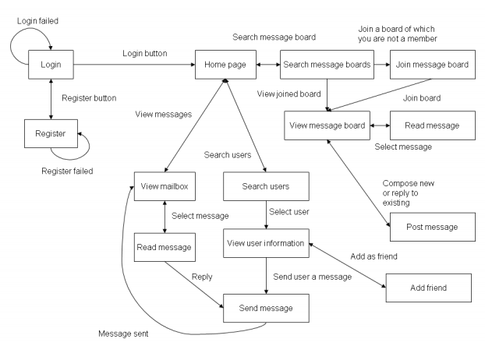

Figure 3.1 Client Screen Flow

### Use case diagrams.

A use case diagram is a graphic depiction of the interactions among the elements of a system. A use case is a methodology used in system analysis to identify, clarify, and organize system requirements. In this context, the term "system" refers to something being developed or operated, such as a mail-order product sales and service Web site. Use case diagrams are employed in UML (Unified Modeling Language), a standard notation for the modeling of real-world objects and systems.

System objectives can include planning overall requirements, validating a hardware design, testing and debugging a software product under development, creating an online help reference, or performing a consumer-service-oriented task. For example, use cases in a product sales environment would include item ordering, catalog updating, payment processing, and customer relations. A use case diagram contains four components. The boundary, which defines the system of interest in relation to the world around it.

* The actors, usually individuals involved with the system defined according to their roles.
* The use cases, which are the specific roles played by the actors within and around the system.
* The relationships between and among the actors and the use cases.
* **Login/Registration**



Fig 3.2 Login/Registration

* **Home Page**

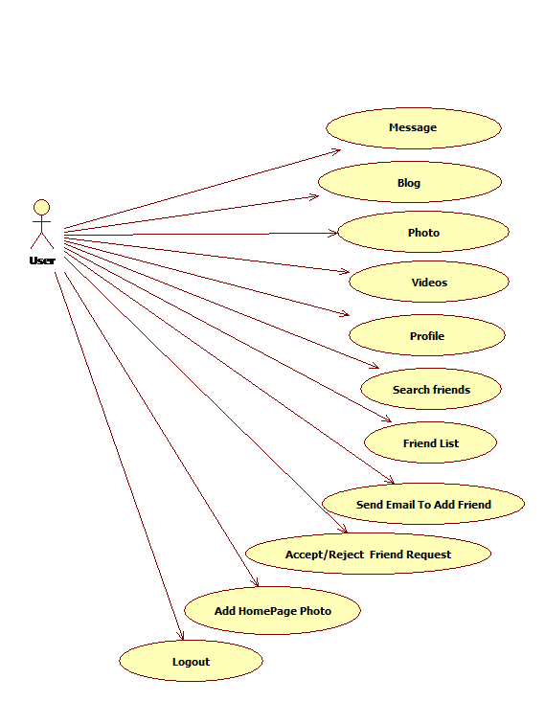

Fig 3.3 homepage

#### Wall Page



Fig 3.4 Wall page

#### Blog Page



Fig 3.5 Blog page

#### Profile Page



Fig 3.6 Profile page

#### Search Friend Page



Fig 3.7 Search friend page

#### Friend List Page



Fig 3.8 Friend List Page

#### Photo Page



Fig 3.9 Photo page

**Data Flow Diagram of the Proposed System**

UUuUUUUUU

**ADMIN**

**USER**

Response received

Login

Views Personal detail Response received

Send Invitation

Views Mail Message

Detail Entered new data or existing

data update

Fig 3.10 0 level DFD

**DFD Level-0**

**0 Level DFD:** A level 0 DFD, also called a fundamental system model or context diagram represents the entire software element as a single bubble with input and output data indicated by incoming and outgoing arrows, respectively.

**DFD: Level 1:-**

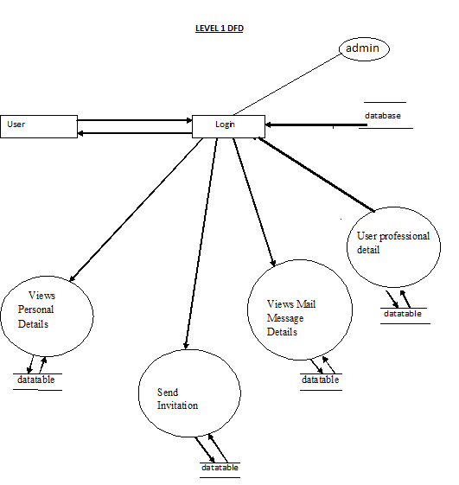

**DFD Level 1**

The above shown diagram is a 1-level Data Flow Diagram for the voting system. According to this DFD various process are done after login process. The Administrator can register voter. The ELECTION COMMISION can register the voters and voter can use their voting rights. The voter can view the final report after giving vote..

**Feasibility Analysis**

Depending on the results of the initial investigation the survey is now expanded to a more detailed feasibility study. “***FEASIBILITY STUDY***” is a test of system proposal according to its workability, impact of the organization, ability to meet needs and effective use of the resources. It focuses on these major questions:

1. What are the user’s demonstrable needs and how does a candidate system meet them?

2. What resources are available for given candidate system?

3. What are the likely impacts of the candidate system on the organization?

4. Whether it is worth to solve the problem?

During feasibility analysis for this project, following primary areas of interest are to be considered. Investigation and generating ideas about a new system does this.

Steps in feasibility analysis

Eight steps involved in the feasibility analysis are:

* Form a project team and appoint a project leader.
* Prepare system flowcharts.
* Enumerate potential proposed system.
* Define and identify characteristics of proposed system.
* Determine and evaluate performance and cost effective of each proposed system.
* Weight system performance and cost data.
* Select the best-proposed system.
* Prepare and report final project directive to management.

**Technical Feasibility**

A study of resource availability that may affect the ability to achieve an acceptable system. This evaluation determines whether the technology needed for the proposed system is available or not.

* Can the work for the project be done with current equipment existing software technology & available personal?
* Can the system be upgraded if developed?
* If new technology is needed then what can be developed?
* This is concerned with specifying equipment and software that will successfully satisfy the user requirement. The technical needs of the system may include:

**ER Diagram**

The entity relationship model is a high level data model. It is based on a perception of a real world that consists of a collection of basic objects, called entities, and of relationship among these objects. It was developed to facilitate database design by allowing specification of an enterprise schema, which represent the overall logical structure of a database.

**Entity:** An entity is an object that has its existence in the real world. It includes all those “things” about which data is collected. An entity may be a tangible object such as a student, a place or a part. It may also be non-tangible such as an event, a job title or a customer account. For example, if we say that a customer buys goods, it means customer and goods are entities.

Diagrammatically, entities are represented in rectangles.

**An Entity Set**: It is a set of entities of the same type that share the same properties, or attributes. The set of all persons who are customers at a given bank, example, can be defined as the entity set customer.

**Attributes**: Attributes are units that describe the characteristics or properties of entities. In a database, entities are represented by tables and attributes by columns. For example, a customer entity might have numerous attributes such as code, name and addresses. Similarly, the goods entity may have attributes like code and price. They are drawn in elliptical shapes along with the entity rectangles.

The entity relationship diagram of chatterbox is drawn on the next page:

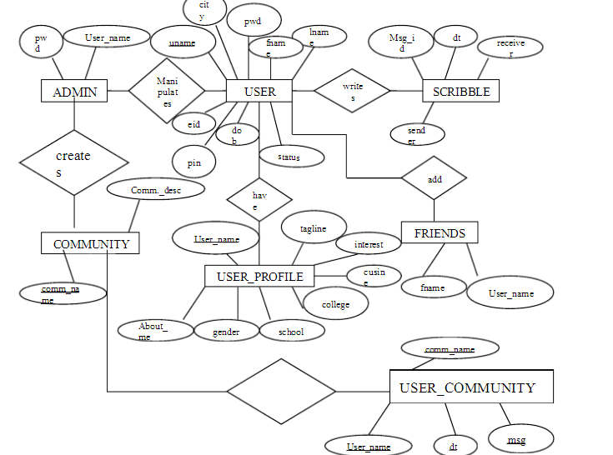

**Database**

Data base is used to store the relevant information of the individuals. A database is a collection of rows and columns in which rows indicates the tuple and column indicates the domain of table. Database design is the process of producing a detailed data model of a database. This logical data model contains all the needed logical and physical design choices and physical storage parameters. Need to generate a design in a data definition language, which can then be used to create a database. A fully attributed data model contains detailed attributes for each entity. The term database design can be used to describe many different parts of the design of an overall database system. Principally, and most correctly, it can be thought of the logical design of the relation of the base data structures used to store the data. In the relational model these are the classes and named relationships. However, the term database design could also be used to apply to overall process of designing, not just the base data structure, but also the forms and queries used as part of the overall database application within the database management system (DBMS).

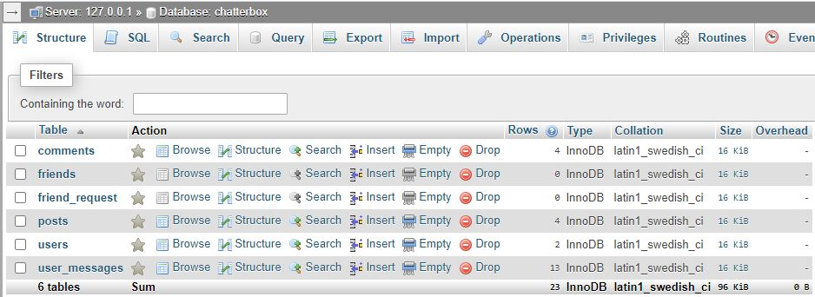

**Data Dictionary**

Database is a collection of related data items which represent the aspect of real-world object. A database system is design to be built and populate with a data for certain task.

**New User**

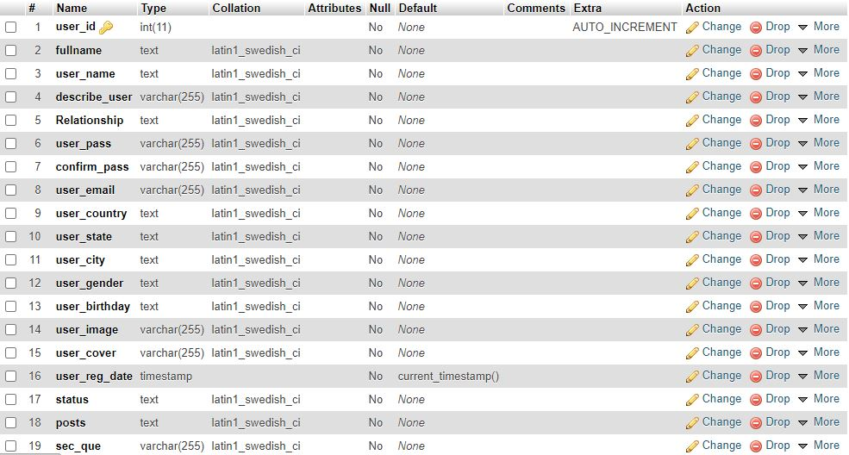

**Comment**

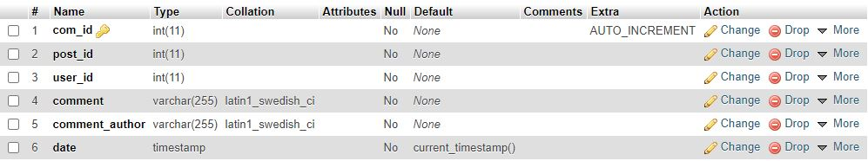

**Post**

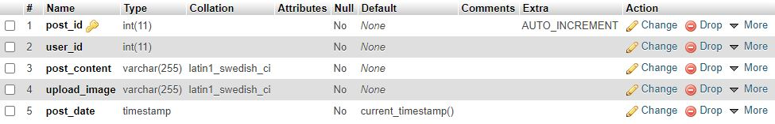

**Message**

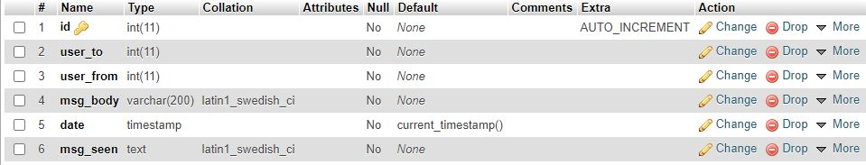

**H/W and S/W Requirement**

**Hardware Requirement**

Processor : Intel Pentium IV 2.0 GHz and above

RAM : 512 MB and above

Hard disk : 80GB and above

Monitor : CRT or LCD monitor

Keyboard : Normal or Multimedia

Mouse : Compatible mouse

**Software Requirements**

Front End : LAMP

Language : PHP

Back End : PHP MyAdmin

Operation System : Windows XP or above

Browser : Any latest browser

**Screenshots & Coding**

**Register New User**

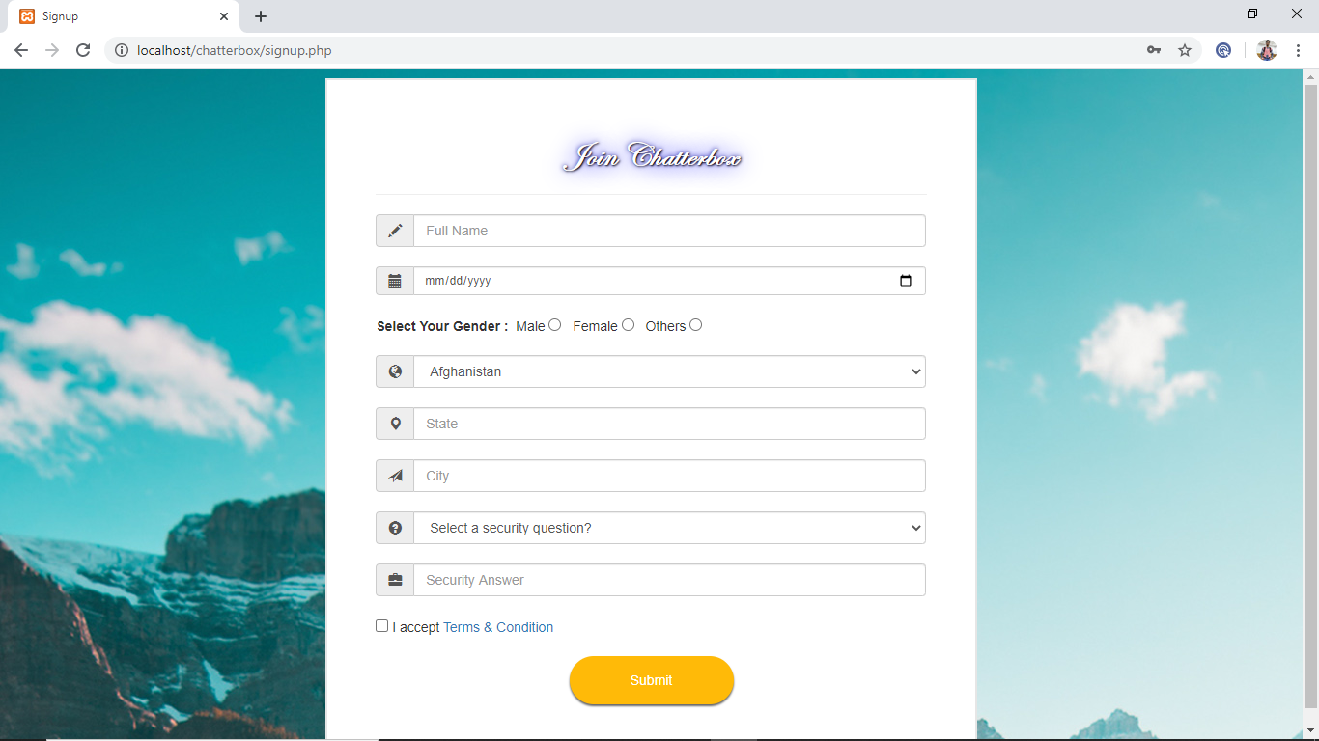

<!DOCTYPE html>

<?php

session_start();

include("includes/connection.php");

$_SESSION['email'] = $_POST['eml'];

$_SESSION['password'] = $_POST['pas'];

$_SESSION['c_password'] = $_POST['c_pas'];

$email = $_SESSION['email'];

if(strlen($_SESSION['password'])<12){

echo "<script>alert('Password should be minimum 12 characters!')</script>";

echo "<script>window.open('index.php','_self')</script>";

exit();

}

$check_email = "select * from users where user_email='$email'";

$run_email = mysqli_query($con,$check_email);

$check = mysqli_num_rows($run_email);

if($check==1){

echo "<script>alert('Email already exist, please try another!')</script>";

echo "<script>window.open('index.php','_self')</script>";

exit();

}

?>

<html>

<head>

<title>Signup</title>

<meta charset="utf-8">

<meta name="viewport" content="width=device-width, initial-scale=1">

<link rel="stylesheet" href="https://maxcdn.bootstrapcdn.com/bootstrap/3.3.7/css/bootstrap.min.css">

<script src="https://ajax.googleapis.com/ajax/libs/jquery/3.3.1/jquery.min.js"></script>

<script src="https://maxcdn.bootstrapcdn.com/bootstrap/3.3.7/js/bootstrap.min.js"></script>

<script src="https://kit.fontawesome.com/81c2c05f29.js" crossorigin="anonymous"></script>

<script src="bootstrap/js/sweetalert.min.js"></script>

</head>

<style>

body{

overflow-x: hidden;

}

.main-content{

width: 50%;

height: 40%;

margin: 10px auto;

background-color: #fff;

border: 2px solid #e6e6e6;

padding: 40px 50px;

}

.header{

border: 0px solid #000;

margin-bottom: 5px;

}

.well{

background-color: #187FAB;

}

#footer

{

background-color: black;

color: white;

position: fixed;

text-align: center;

padding-top: 5px;

height: 30px;

left: 0;

bottom: 0;

width: 100%;

}

.btn {

width: 170px;

height: 50px;

padding: 5px 0;

border: 0;

border-radius: 30px;

outline: 0;

position: relative;

overflow: hidden;

transition: 0.2s ease-in-out;

box-shadow: 0 2px 2px rgba(0, 0, 0, 0.6);

opacity: 1;

background: #ffba08;

color: #fff;

}

.btn-text {

font-size: 1em;

}

.btn .btn-icon {

position: absolute;

top: 50%;

left: 50%;

transform: translate(-50%, -50%);

display: none;

}

.btn:hover {

cursor: pointer;

box-shadow: 0 10px 20px rgba(0, 0, 0, 0.6);

}

.sending .btn-text {

opacity: 1;

animation: 0.5s ease-out fadeOut forwards;

animation-delay: 0.5s;

}

.sending .btn-icon {

display: block;

opacity: 0;

animation: 0.6s ease-in-out iconAnimation forwards;

animation-delay: 1s;

}

.sent {

background: #04db5e;

color: #fff;

}

@keyframes iconAnimation {

20% {

opacity: 1;

}

25% {

left: 45%;

}

50% {

left: 105%;

opacity: 0;

}

55% {

left: -5%;

}

100% {

left: 50%;

opacity: 1;

}

}

@keyframes fadeOut {

to {

opacity: 0;

}

}

</style>

<body background="images/banner.jpg">

<div class="row">

<div class="col-sm-12">

<div class="main-content">

<div class="header">

<h3 style="text-align: center;font-family:Edwardian Script ITC;font-size: 35px;"><strong style="color: white;

text-shadow: 1px 1px 2px black, 0 0 25px blue, 0 0 5px darkblue;">Join Chatterbox</strong></h3><hr></div>

<div class="l-part">

<form action="register_user.php" method="post">

<div class="input-group">

<span class="input-group-addon"><i class="glyphicon glyphicon-pencil"></i></span>

<input type="text" class="form-control" placeholder="Full Name" name="full_name" required="required">

</div><br>

<div class="input-group">

<span class="input-group-addon"><i class="glyphicon glyphicon-calendar"></i></span>

<input type="date" class="form-control input-sm" name="birthday" required>

</div><br>

<div class="input-group">

<b>Select Your Gender :</b>&nbsp

Male <input type="radio" id="r1" name="gen" onclick="gender(r1);" value="male"> &nbsp

Female <input type="radio" id="r2" name="gen" onclick="gender(r2);" value="female"> &nbsp

Others <input type="radio" id="r2" name="gen" onclick="gender(r3);" value="others">

</div><br>

<div class="input-group">

<span class="input-group-addon"><i class="glyphicon glyphicon-globe"></i></span>

<select class="form-control" name="cnt" required="required">

<option disabled>Select your Country</option>

<option>Afghanistan</option>

<option>Albania</option>

<option>Algeria</option>

<option>Andorra</option>

<option>Angola</option>

<option>Antigua and Barbuda</option>

<option>Argentina</option>

<option>Armenia</option>

<option>Australia</option>

<option>Austria</option>

<option>Austrian Empire</option>

<option>Azerbaijan</option>

<option>Baden</option>

<option>Bahamas</option>

<option>Bahrain</option>

<option>Bangladesh</option>

<option>Barbados</option>

<option>Bavaria</option>

<option>Belarus</option>

<option>Belgium</option>

<option>Belize</option>

<option>Benin</option>

<option>Bolivia</option>

<option>Bosnia and Herzegovina</option>

<option>Botswana</option>

<option>Brazil</option>

<option>Brunei</option>

<option>Brunswick and Lüneburg</option>

<option>Bulgaria</option>

<option>Burkina Faso</option>

<option>Burma</option>

<option>Burundi</option>

<option>Cabo Verde</option>

<option>Cambodia</option>

<option>Cameroon</option>

<option>Canada</option>

<option>Cayman Islands</option>

<option>Central African Republic</option>

<option>Central American Federation</option>

<option>Chad</option>

<option>Chile</option>

<option>China</option>

<option>Colombia</option>

<option>Comoros</option>

<option>Congo Free State</option>

<option>Costa Rica</option>

<option>Cote d’Ivoire</option>

<option>Croatia</option>

<option>Cuba</option>

<option>Cyprus</option>

<option>Czechia</option>

<option>Czechoslovakia</option>

<option>Democratic Republic of the Congo</option>

<option>Denmark</option>

<option>Djibouti</option>

<option>Dominica</option>

<option>Dominican Republic</option>

<option>Duchy of Parma</option>

<option>East Germany</option>

<option>Ecuador</option>

<option>Egypt</option>

<option>El Salvador</option>

<option>Equatorial Guinea</option>

<option>Eritrea</option>

<option>Estonia</option>

<option>Eswatini</option>

<option>Ethiopia</option>

<option>Federal Government of Germany</option>

<option>Fiji</option>

<option>Finland</option>

<option>France</option>

<option>Gabon</option>

<option>Gambia</option>

<option>Georgia</option>

<option>Germany</option>

<option>Ghana</option>

<option>Grand Duchy of Tuscany</option>

<option>Greece</option>

<option>Grenada</option>

<option>Guatemala</option>

<option>Guinea</option>

<option>Guinea-Bissau</option>

<option>Guyana</option>

<option>Haiti</option>

<option>Hanover</option>

<option>Hanseatic Republics</option>

<option>Hawaii</option>

<option>Hesse</option>

<option>Holy See</option>

<option>Honduras</option>

<option>Hungary</option>

<option>Iceland</option>

<option>India</option>

<option>Indonesia</option>

<option>Iran</option>

<option>Iraq</option>

<option>Ireland</option>

<option>Israel</option>

<option>Italy</option>

<option>Jamaica</option>

<option>Japan</option>

<option>Jordan</option>

<option>Kazakhstan</option>

<option>Kenya</option>

<option>Kingdom of Serbia/Yugoslavia</option>

<option>Kiribati</option>

<option>Korea</option>

<option>Kosovo</option>

<option>Kuwait</option>

<option>Kyrgyzstan</option>

<option>Laos</option>

<option>Latvia</option>

<option>Lebanon</option>

<option>Lesotho</option>

<option>Lew Chew </option>

<option>Liberia</option>

<option>Libya</option>

<option>Liechtenstein</option>

<option>Lithuania</option>

<option>Luxembourg</option>

<option>Madagascar</option>

<option>Malawi</option>

<option>Malaysia</option>

<option>Maldives</option>

<option>Mali</option>

<option>Malta</option>

<option>Marshall Islands</option>

<option>Mauritania</option>

<option>Mauritius</option>

<option>Mecklenburg-Schwerin</option>

<option>Mecklenburg-Strelitz</option>

<option>Mexic</option>

<option>Micronesia</option>

<option>Moldova</option>

<option>Monaco</option>

<option>Mongolia</option>

<option>Montenegro</option>

<option>Morocco</option>

<option>Mozambique</option>

<option>Namibia</option>

<option>Nassau</option>

<option>Nauru</option>

<option>Nepal</option>

<option>Netherlands</option>

<option>New Zealand</option>

<option>Nicaragua</option>

<option>Niger</option>

<option>Nigeria</option>

<option>North German Confederation</option>

<option>North German Union</option>

<option>North Macedonia</option>

<option>Norway</option>

<option>Oldenburg</option>

<option>Oman</option>

<option>Orange Free State</option>

<option>Pakistan</option>

<option>Palau</option>

<option>Panama</option>

<option>Papal States</option>

<option>Papua New Guinea</option>

<option>Paraguay</option>

<option>Peru</option>

<option>Philippines</option>

<option>Piedmont-Sardinia</option>

<option>Polan</option>

<option>Portugal</option>

<option>Qatar</option>

<option>Republic of Genoa</option>

<option>Republic of Korea (South Korea)</option>

<option>Republic of the Congo</option>

<option>Romania</option>

<option>Russia</option>

<option>Rwanda</option>

<option>Saint Kitts and Nevis</option>

<option>Saint Lucia</option>

<option>Saint Vincent and the Grenadines</option>

<option>Samoa</option>

<option>San Marino</option>

<option>Sao Tome and Principe</option>

<option>Saudi Arabia</option>

<option>Schaumburg-Lippe</option>

<option>Senegal</option>

<option>Serbia</option>

<option>Seychelles</option>

<option>Sierra Leone</option>

<option>Singapore</option>

<option>Slovakia</option>

<option>Slovenia</option>

<option>Solomon Islands</option>

<option>Somalia</option>

<option>South Africa</option>

<option>South Sudan</option>

<option>Spain</option>

<option>Sri Lanka</option>

<option>Sudan</option>

<option>Suriname</option>

<option>Sweden</option>

<option>Switzerland</option>

<option>Syria</option>

<option>Tajikistan</option>

<option>Tanzania</option>

<option>Texas</option>

<option>Thailand</option>

<option>Timor-Leste</option>

<option>Togo</option>

<option>Trinidad and Tobago</option>

<option>Tunisia</option>

<option>Turkey</option>

<option>Turkmenistan</option>

<option>Tuvalu</option>

<option>Two Sicilies</option>

<option>Uganda</option>

<option>Ukraine</option>

<option>Union of Soviet Socialist Republics</option>

<option>United Arab Emirates</option>

<option>United Kingdom</option>

<option>Uruguay</option>

<option>Uzbekistan</option>

<option>Vanuatu</option>

<option>Venezuela</option>

<option>Vietnam</option>

<option>Württemberg</option>

<option>Yemen</option>

<option>Zambia</option>

<option>Zimbabwe</option>

</select></div><br>

<div class="input-group">

<span class="input-group-addon"><i class="glyphicon glyphicon-map-marker"></i></span>

<input type="text" class="form-control" placeholder="State" name="state" required="required">

</div><br>

<div class="input-group">

<span class="input-group-addon"><i class="glyphicon glyphicon-send"></i></span>

<input type="text" class="form-control" placeholder="City" name="city" required="required">

</div><br>

<div class="input-group">

<span class="input-group-addon"><i class="glyphicon glyphicon-question-sign"></i></span>

<select class="form-control" name="ques" required="required">

<option>Select a security question?</option>

<option>What is your pet name?</option>

<option>Your first phone number?</option>

<option>Your best friend name?</option>

<option>First vehicle?</option>

<option>Primary school?</option>

</select></div><br>

<div class="input-group">

<span class="input-group-addon"><i class="glyphicon glyphicon-briefcase"></i></span>

<input type="text" class="form-control" name="ans" placeholder="Security Answer">

</div><br>

<div class="input-group">

<input type="checkbox" value="Copy" id="item" required> I accept

<a href=""> Terms & Condition</a>

</div><br>

<center><span class="btn-text"><input type="submit" value="Submit" id="signup" class="btn "></span>

<i class="fas fa-long-arrow-alt-right btn-icon"></i></center></form></div></div></div></div></div></div>

<script type="text/javascript">

const btn = document.querySelector('.btn');

const btnText = document.querySelector('.btn .btn-text');

const btnIcon = document.querySelector('.btn .btn-icon');

btn.addEventListener('click', () => {btn.classList.add('sending');

btnText.innerHTML = 'Submiting...';

setTimeout(() => {btn.classList.remove('sending');

btnText.innerHTML = '<i class="fas fa-check"></i>';

btn.classList.add('sent');}, 2000);});

</script>

</body>

</html>

**Login Page**

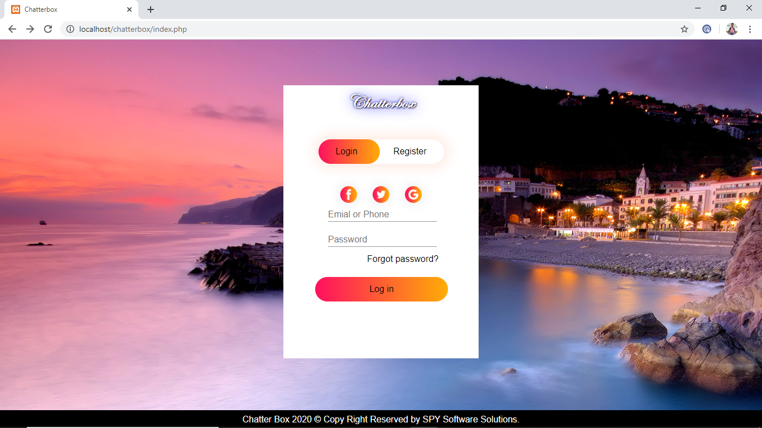

<!DOCTYPE html>

<html><head>

<title>Chatterbox</title>

<link rel="stylesheet" href="bootstrap/css/bootstrap.min.css">

<link href="https://cdnjs.cloudflare.com/ajax/libs/font-awesome/5.11.2/css/all.css" rel="stylesheet"/>

<link href="https://fonts.googleapis.com/css?family=Roboto&display=swap" rel="stylesheet”/>

<script src="bootstrap/jQuery/jQuery.min.js"></script>

<script src="bootstrap/js/bootstrap.min.js"></script>

<script src="bootstrap/js/sweetalert.min.js"></script>

<script>

function validatePassword(password) {

if (password.length === 0) {

document.getElementById("msg").innerHTML = "";

return;

}

var matchedCase = new Array();

matchedCase.push("[$@$!%*#?&]");

matchedCase.push("[A-Z]");

matchedCase.push("[0-9]");

matchedCase.push("[a-z]");

var ctr = 0;

for (var i = 0; i < matchedCase.length; i++) {

if (new RegExp(matchedCase[i]).test(password)) {

ctr++;

} }

var color = "";

var strength = "";

switch (ctr) {

case 0:

case 1:

case 2:

strength = "Very Weak";

color = "red";

break;

case 3:

strength = "Medium";

color = "orange";

break;

case 4:

strength = "Strong";

color = "green";

break; }

document.getElementById("msg").innerHTML = strength;

document.getElementById("msg").style.color = color;

} </script>

<script src="jquery-3.3.1.min.js"></script>

<script>

function password_match(){

var password1 = document.getElementById('pwd').value ;

var password2 = document.getElementById('pwd2').value ;

$.post("check.php", {

pass1: password1, pass2: password2

},

function(data, status){

document.getElementById('show-result').innerHTML = data ;

} ) ; } </script>

<style>

* { margin:0;

padding:0;

font-family: sans-serif;

}.hero

{ height: 100%;

width: 100%;

background-position: center;

background-size: cover;

position: absolute;

}#brand

{ font-weight: 800;

font-size: 35px;

font-family:Edwardian Script ITC;

text-decoration: none;

text-decoration-style: none;

}.form-box

{ text-align:center;

width: 350px;

height: 490px;

position: relative;

margin: 6% auto;

background: #fff;

padding: 5px;

overflow: hidden;

}.form-box a

{ color:black;

text-decoration: none;

cursor:pointer;

}.button-box

{ margin-top: 35px;

width: 225px;

margin: 40px auto;

position: relative;

box-shadow: 0 0 20px 9px #ff61241f;

border-radius: 30px;

}.toggle-btn

{ padding:10px 30px;

cursor:pointer;

background:transparent;

border: 0;

outline: none;

position: relative;

}#btn

{ top: 0;

left: 0;

position: absolute;

width: 110px;

height: 100%;

background:linear-gradient(to right,#ff105f,#ffad06);

border-radius: 30px;

transition: .5s;

}.social-icons

{ margin: 30px auto;

text-align: center;

}.social-icons img

{ width: 30px;

margin: 0 12px;

box-shadow: 0 0 20px 0 #7f7f7f3d;

cursor: pointer;

border-radius: 50%;

}.input-group

{ top: 210px;

position: absolute;

width: 280px;

transition: .5s;

}.input-field

{ width: 100%

padding:20px 0;

margin: 10px 60px;

border-left: 0;

border-top: 0;

border-right: 0;

border-bottom: 1px solid #999;

outline: none;

background:transparent;

}.submit-btn

{ width: 85%;

padding:10px 30px;

cursor: pointer;

display: block;

margin:auto;

background:linear-gradient(to right,#ff105f,#ffad06);

border:0;

outline: none;

border-radius: 30px;

}#login

{left: 20px;

}#register

{left: 400px;

}#footer

{ background-color: black;

color: white;

position: fixed;

text-align: center;

padding-top: 5px;

height: 30px;

left: 0;

bottom: 0;

width: 100%;}

#footer a{

color: white;

text-decoration: none;

} </style></head>

<body background="images/37.jpg">

<div class="hero">

<div class="form-box">

<a href="#" id=brand style=" color: white;

text-shadow: 1px 1px 2px black, 0 0 25px blue, 0 0 5px darkblue;"> Chatterbox</a>

<div class="button-box">

<div id="btn"></div>

<button type="button" class="toggle-btn" onclick="login()" >Login</button>

<button type="button" class="toggle-btn" onclick="register()">Register</button>

</div>

<div class="social-icons">

<img src="images/fb.png">

<img src="images/tw.png">

<img src="images/gp.png">

</div>

<form id="login" class="input-group" method="post" action="login.php">

<input type="email" class="input-field" placeholder="Emial or Phone" required autocomplete="off" name="email">

<input type="Password" class="input-field" placeholder="Password" required autocomplete="off" name="pass">

<a href="forgot_password.php" style="margin-left: 130px;">Forgot password?</a>

<button type="submit" class="submit-btn"style="margin-top:20px; margin-right:5px;" name="login">Log in</button>

</form>

<form id="register" class="input-group" method="post" action="signup.php">

<input type="email" class="input-field" placeholder="Emial or Phone" required autocomplete="off" name="eml">

<input type="Password" class="input-field" placeholder="New Password" required autocomplete="off" name="pas"

id="pwd" onkeyup="validatePassword(this.value);"/><span id="msg" style="padding-left:60px;"></span>

<input type="Password" class="input-field" placeholder="Confirm Password" required autocomplete="off" name="c_pas" id="pwd2" onfocusout="password_match()">

<div id="show-result" style="padding-left:60px;">

</div>

<input type="submit" value="Register" style="width: 85%;padding:10px 30px;cursor:pointer;display: block;margin:auto;background:linear-gradient(to right,#ff105f,#ffad06);border:0;outline:none;border-radius:30px;margin-top:20px; margin-right:5px;"></form></div>

<div id="footer">

Chatter Box 2020 &copy; Copy Right Reserved by <a href="https://mahboobhasan.000webhostapp.com"> SPY Software Solutions.</a>

</div> </div> <script>

var x = document.getElementById("login");

var y = document.getElementById("register");

var z = document.getElementById("btn");

function register() {

x.style.left = "-400px";

y.style.left = "20px";

z.style.left = "110px";

}

function login() {

x.style.left = "20px";

y.style.left = "400px";

z.style.left = "0px";

}

</script></body>

</html>

**Home Page**

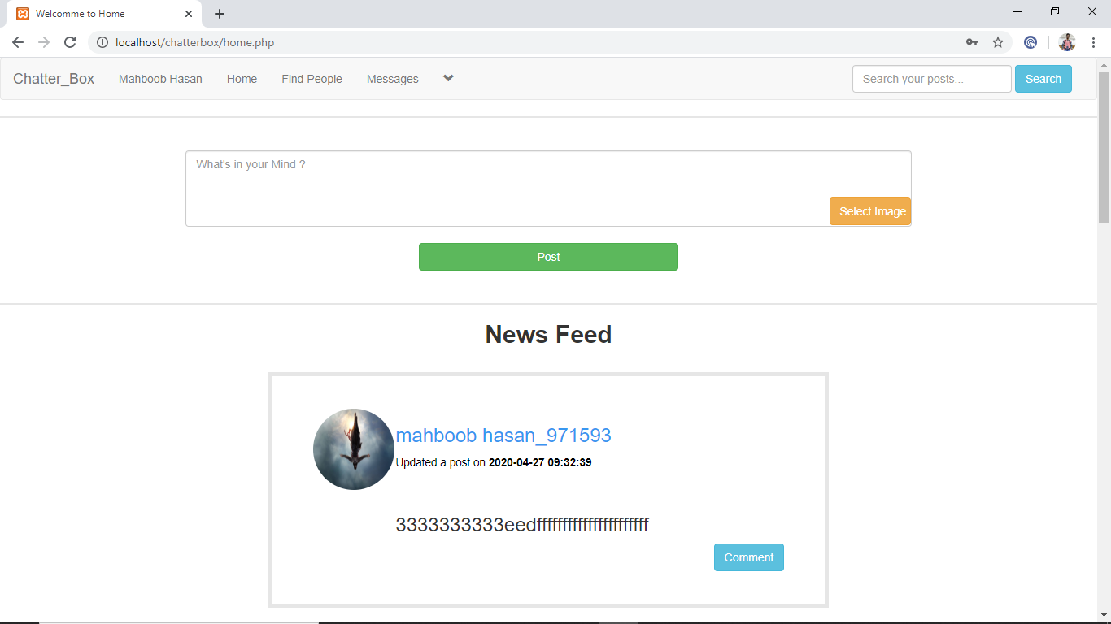

<!DOCTYPE html>

<?php

session_start();

include("includes/header.php");?>

<?php

if(!isset($_SESSION['user_email'])){

header("location: index.php");

}

else{ ?>

<html>

<head>

<title>Welcomme to Home</title>

<meta charset="utf-8">

<meta name="viewport" content="width=device-width, initial-scale=1">

<link rel="stylesheet" href="https://maxcdn.bootstrapcdn.com/bootstrap/3.3.7/css/bootstrap.min.css">

<script src="https://ajax.googleapis.com/ajax/libs/jquery/3.3.1/jquery.min.js"></script>

<script src="https://maxcdn.bootstrapcdn.com/bootstrap/3.3.7/js/bootstrap.min.js"></script>

<link rel="stylesheet" href="styles/home_style2.css" media="all"/>

</head>

<body>

<div class="row">

<div id="insert_post" class="col-sm-12">

<center>

<form action="home.php <?php $id=$user_id;?>" method="post" id="f" enctype='multipart/form-data'>

<textarea class="form-control" id="content" rows="4" name="content" placeholder="What's in your Mind ?"></textarea><br/>

<label class="btn btn-warning" id="upload_image_button"> Select Image

<input type='file' name='upload_image' size="30" />

</label>

<button id="btn-post" class="btn btn-success" name="sub">Post</button>

</form>

<?php insertPost();?>

</center>

</div>

</div>

<div class="row">

<div class="col-sm-12">

<center><h2><strong>News Feed</strong></h2><br></center>

<?php get_posts();?>

</div>

</div>

</body>

</html>

<?php } ?>

**Profile Page**

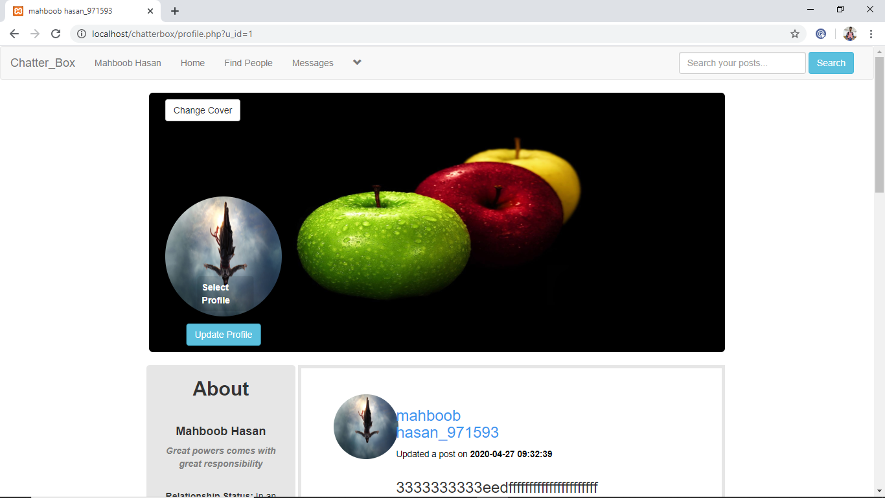

<!DOCTYPE html>

<?php

session_start();

include("includes/header.php");

if(!isset($_SESSION['user_email'])){

header("location: index.php");

}

else{ ?>

<html>

<head>

<?php

$user = $_SESSION['user_email'];

$get_user = "select * from users where user_email='$user'";

$run_user = mysqli_query($con,$get_user);

$row=mysqli_fetch_array($run_user);

$user_id = $row['user_id'];

$user_name = $row['user_name'];

?>

<title><?php echo"$user_name"; ?></title>

<meta charset="utf-8">

<meta name="viewport" content="width=device-width, initial-scale=1">

<link rel="stylesheet" href="https://maxcdn.bootstrapcdn.com/bootstrap/3.3.7/css/bootstrap.min.css">

<script src="https://ajax.googleapis.com/ajax/libs/jquery/3.3.1/jquery.min.js"></script>

<script src="https://maxcdn.bootstrapcdn.com/bootstrap/3.3.7/js/bootstrap.min.js"></script>

<link rel="stylesheet" href="styles/home_style2.css" media="all"/>

</head>

<style>

#cover-img{

height:400px;

width:100%;

}

#profile_img{

position: absolute;

top: 160px;

left: 40px;

}

#update_profile{

position: absolute;

top: 150px;

cursor: pointer;

left: 93px;

border-radius: 4px;

background-color: rgba(0,0,0,0.1);

transform: translate(-50%, -50%);

}

#button_profile{

position: absolute;

top: 115%;

left: 50%;

cursor: pointer;

transform: translate(-50%, -50%);

}

#own_posts{

border: 5px solid #e6e6e6;

padding: 40px 50px;

}

#posts_img {

height:300px;

width:100%;

}</style>

<body>

<div class="row">

<div class="col-sm-2">

</div>

<div class="col-sm-8">

<?php

echo "

<div>

<div><img id='cover-img' class='img-rounded' src='cover/$user_cover' alt='cover'/></div>

<form action='profile.php?u_id=$user_id' method='post' enctype='multipart/form-data'>

<ul class='nav pull-left' style='position: absolute;top: 10px;left: 40px;'>

<li class='dropdown'>

<button class='dropdown-toggle btn btn-default' data-toggle='dropdown'>Change Cover</button>

<div class='dropdown-menu'>

<center>

<p> Click <strong>Select Cover</strong> and then click the <br> <strong>Update Cover</strong></p>

<label class='btn btn-info'> Select Cover

<input type='file' name='u_cover' size='60' />

</label><br><br>

<button name='submit' class='btn btn-info'>Update cover</button>

</center></div></li></ul></form></div>

<div id='profile_img'>

<img src='users/$user_image' alt='Profile' class='img-circle' width='180px' height='185px' />

<form action='profile.php?u_id=$user_id' method='post' enctype='multipart/form-data'>

<label id='update_profile'> Select Profile

<input type='file' name='u_image' size='60' />

</label>

<button id='button_profile' name='update' class='btn btn-info'>Update Profile</button>

</form></div><br> "; ?>

<?php

if(isset($_POST['submit'])){

$u_cover = $_FILES['u_cover']['name'];

$image_tmp = $_FILES['u_cover']['tmp_name'];

$random_number = rand(1,100);

if($u_cover==''){

echo "<script>alert('Please Select Cover Image!')</script>";

echo "<script>window.open('profile.php?u_id=$user_id','_self')</script>";

exit();

}else{

move_uploaded_file($image_tmp,"cover/$u_cover.$random_number");

$update = "update users set user_cover='$u_cover.$random_number' where user_id='$user_id'";

$run = mysqli_query($con,$update);

if($run){

echo "<script>alert('Your Cover Updated!')</script>"

echo"<script>window.open('profile.php?u_id=$user_id','_self')</script>";

} } } ?>

</div>

<?php

if(isset($_POST['update'])){

$u_image = $_FILES['u_image']['name'];

$image_tmp = $_FILES['u_image']['tmp_name'];

$random_number = rand(1,100);

if($u_image==''){

echo "<script>alert('Please Select Profile Image on clicking on the profile image area!')</script>";

echo "<script>window.open('profile.php?u_id=$user_id','_self')</script>";

exit();

}else{

move_uploaded_file($image_tmp,"users/$u_image.$random_number");

$update = "update users set user_image='$u_image.$random_number' where user_id='$user_id'";

$run = mysqli_query($con,$update);

if($run){

echo "<script>alert('Your Profile Updated!')</script>";

echo "<script>window.open('profile.php?u_id=$user_id','_self')</script>";

} } } ?>

<div class="col-sm-2">

</div>

</div>

<div class="row">

<div class="col-sm-2">

</div>

<div class="col-sm-2" style="background-color: #e6e6e6; text-align: center; left:0.8%; border-radius: 5px;">

<?php

echo"

<center><h2><strong>About</strong></h2></center><br>

<center><h4><strong>$first_name</strong></h4></center>

<p><strong><i style='color:grey;'> $describe_user</i></strong></p><br>

<p><strong>Relationship Status: </strong> $Relationship_status</p><br>

<p><strong>Lives In: </strong> $user_country</p><br>

<p><strong>Member Since: </strong> $register_date</p><br>

<p><strong>Gender: </strong> $user_gender</p><br>

<p><strong>Date Of Birth: </strong> $user_birthday</p><br>

";?>

</div>

<div class="col-sm-6">

<!--Displaying Users own Posts-->

<?php

global $con;

if(isset($_GET['u_id'])){

$u_id = $_GET['u_id'];

}

$get_posts = "select * from posts where user_id='$u_id' ORDER by 1 DESC LIMIT 5";

$run_posts = mysqli_query($con,$get_posts);

while($row_posts=mysqli_fetch_array($run_posts)){

$post_id = $row_posts['post_id'];

$user_id = $row_posts['user_id'];

$content = $row_posts['post_content'];

$upload_image = $row_posts['upload_image'];

$post_date = $row_posts['post_date'];

$user = "select * from users where user_id='$user_id' AND posts='yes'";

$run_user = mysqli_query($con,$user);

$row_user=mysqli_fetch_array($run_user);

$user_name = $row_user['user_name'];

$user_image = $row_user['user_image'];

if($content=="No" && strlen($upload_image) >= 1){

echo "

<div id='own_posts'>

<div class='row'>

<div class='col-sm-2'>

<p><img src='users/$user_image' class='img-circle' width='100px' height='100px'></p>

</div>

<div class='col-sm-6'>

<h3><a style='text-decoration: none;cursor: pointer;color: #3897f0;' href='user_profile.php?u_id=$user_id'>$user_name</a></h3>

<h4><small style='color:black;'>Updated a post on <strong>$post_date</strong></small></h4>

</div>

<div class='col-sm-4'>

</div></div>

<div class='row'>

<div class='col-sm-12'>

<img id='posts-img' src='imagepost/$upload_image' style='height:350px;'>

</div>

</div><br>

<a href='single.php?post_id=$post_id' style='padding-left:413px;'><button class='btn btn-success'>View</button></a>

<a href='functions/delete_post.php?post_id=$post_id' style='float:right;'><button class='btn btn-danger'>Delete</button></a>

</div><br/><br/>

";}

else if(strlen($content) >= 1 && strlen($upload_image) >= 1){

echo "

<div id='own_posts'>

<div class='row'>

<div class='col-sm-2'>

<p><img src='users/$user_image' class='img-circle' width='100px' height='100px'></p>

</div>

<div class='col-sm-6'>

<h3><a style='text-decoration: none;cursor: pointer;color: #3897f0;' href='user_profile.php?u_id=$user_id'>$user_name</a></h3>

<h4><small style='color:black;'>Updated a post on <strong>$post_date</strong></small></h4>

</div>

<div class='col-sm-4'>

</div></div>

<div class='row'>

<div class='col-sm-12'>

<p>$content</p>

<img id='posts-img' src='imagepost/$upload_image' style='height:350px;'>

</div>

</div><br>

<a href='single.php?post_id=$post_id' style='padding-left:413px;'><button class='btn btn-success'>View</button></a>

<a href='functions/delete_post.php?post_id=$post_id' style='float:right;'><button class='btn btn-danger'>Delete</button></a>

</div><br/><br/>

";

} else{

echo "

<div id='own_posts'>

<div class='row'>

<div class='col-sm-2'>

<p><img src='users/$user_image' class='img-circle' width='100px' height='100px'></p>

</div>

<div class='col-sm-6'>

<h3><a style='text-decoration: none;cursor: pointer;color: #3897f0;' href='user_profile.php?u_id=$user_id'>$user_name</a></h3>

<h4><small style='color:black;'>Updated a post on <strong>$post_date</strong></small></h4>

</div>

<div class='col-sm-4'>

</div>

</div>

<div class='row'>

<div class='col-sm-2'>

</div>

<div class='col-sm-6'>

<h3><p>$content</p></h3>

</div>

<div class='col-sm-4'>

</div>

</div>

"; global $con;

if(isset($_GET['u_id'])){

$u_id = $_GET['u_id'];

}

$get_posts = "select user_email from users where user_id='$u_id'";

$run_user = mysqli_query($con,$get_posts);

$row=mysqli_fetch_array($run_user);

$user_email = $row['user_email'];

$user = $_SESSION['user_email'];

$get_user = "select * from users where user_email='$user'";

$run_user = mysqli_query($con,$get_user);

$row=mysqli_fetch_array($run_user);

$user_id = $row['user_id'];

$u_email = $row['user_email'];

if($u_email != $user_email){

echo"<script>window.open('profile.php?u_id=$user_id','_self')</script>";

}else{

echo"

<a href='single.php?post_id=$post_id' style='padding-left:350px;'><button class='btn btn-success'>View</button></a>

<a href='edit_post.php?post_id=$post_id' style='padding-left:10px;'><button class='btn btn-info'>Edit</button></a>

<a href='functions/delete_post.php?post_id=$post_id' style='float:right;'><button class='btn btn-danger'>Delete</button></a>

</div><br/><br/><br/>

";}}

include("functions/delete_post.php");

}?> </div>

<div class="col-sm--2">

</div></div></body></html>

<?php } ?>

**Find New People**

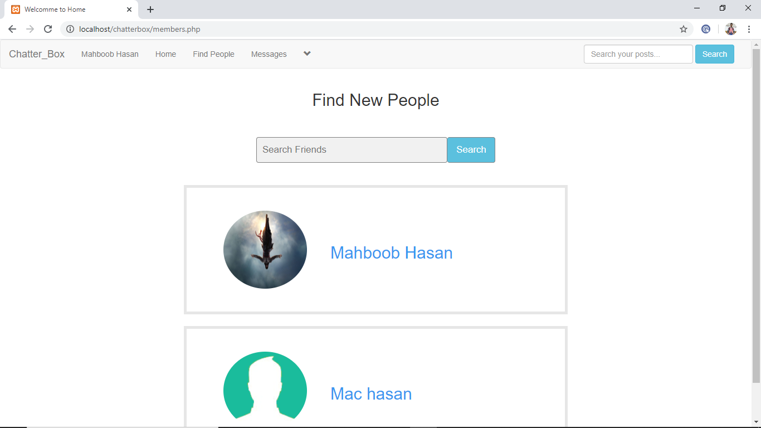

<!DOCTYPE html>

<?php

session_start();

include("includes/header.php");

?>

<?php

if(!isset($_SESSION['user_email'])){

header("location: index.php");}

else{ ?>

<html>

<head>

<title>Welcomme to Home</title>

<meta charset="utf-8">

<meta name="viewport" content="width=device-width, initial-scale=1">

<link rel="stylesheet" href="https://maxcdn.bootstrapcdn.com/bootstrap/3.3.7/css/bootstrap.min.css">

<script src="https://ajax.googleapis.com/ajax/libs/jquery/3.3.1/jquery.min.js"></script>

<scriptsrc="https://maxcdn.bootstrapcdn.com/bootstrap/3.3.7/js/bootstrap.min.js"></script>

<link rel="stylesheet" href="styles/home_style2.css" media="all"/>

</head>

<body>

<div class="row">

<div class="col-sm-12">

<center><h2>Find New People</h2></center><br><br>

<div class="row">

<div class="col-sm-4">

</div>

<div class="col-sm-4">

<form class="search_form" action="">

<input type="text" placeholder="Search Friends" name="search_user">

<button class="btn btn-info" type="submit" name="search_user_btn">Search</button>

</form>

</div>

<div class="col-sm-4">

</div>

</div><br><br>

<?php search_user();?>

</div>

</div>

</body>

</html>

<?php } ?>

**Message**

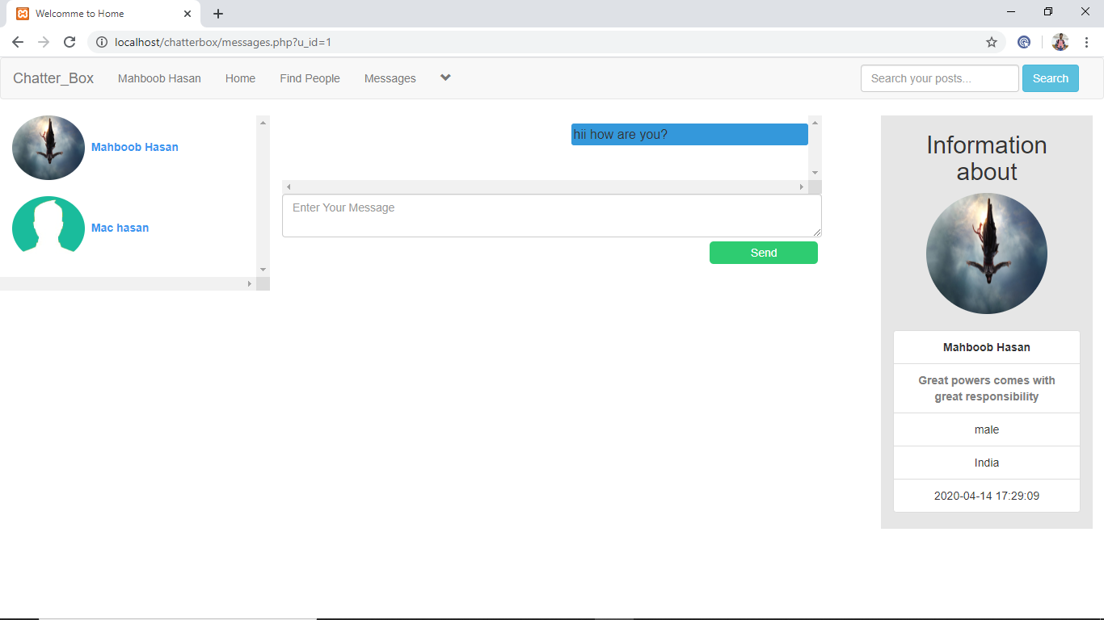

</html><!DOCTYPE html>

<?php

session_start();

include("includes/header.php");

?>

<?php

if(!isset($_SESSION['user_email'])){

header("location: index.php");

}

else{ ?>

<html>

<head>

<title>Welcomme to Home</title>

<meta charset="utf-8">

<meta name="viewport" content="width=device-width, initial-scale=1">

<link rel="stylesheet" href="https://maxcdn.bootstrapcdn.com/bootstrap/3.3.7/css/bootstrap.min.css">

<script src="https://ajax.googleapis.com/ajax/libs/jquery/3.3.1/jquery.min.js"></script>

<script src="https://maxcdn.bootstrapcdn.com/bootstrap/3.3.7/js/bootstrap.min.js"></script>

<link rel="stylesheet" href="styles/home_style2.css" media="all"/>

</head>

<style>

#scroll_messages{

max-height: 500px;

overflow: scroll;

}

#btn-msg{

width: 20%;

height: 28px;

border-radius: 5px;

margin: 5px;

border: none;

color: #fff;

float: right;

background-color: #2ecc71;

}

#select_user{

max-height: 500px;

overflow:scroll;

}

#green{

background-color: #2ecc71;

border-color: #27ae60;

width:45%;

padding:2.5px;

font-size:16px;

border-radius:3px;

float: left;

margin-bottom: 5px;

}

#blue{

background-color: #3498db;

border-color: #2980b9;

width:45%;

padding:2.5px;

font-size:16px;

border-radius:3px;

float: right;

margin-bottom: 5px;

}

</style>

<body>

<div class="row">

<?php

if(isset($_GET['u_id'])){

global $con;

$get_id = $_GET['u_id'];

$get_user = "select * from users where user_id='$get_id'";

$run_user = mysqli_query($con,$get_user);

$row_user=mysqli_fetch_array($run_user);

$user_to_msg = $row_user['user_id'];

$user_to_name = $row_user['user_name'];

}

$user = $_SESSION['user_email'];

$get_user = "select * from users where user_email='$user'";

$run_user = mysqli_query($con,$get_user);

$row=mysqli_fetch_array($run_user);

$user_from_msg = $row['user_id'];

$user_from_name = $row['user_name'];

?>

<div class="col-sm-3" id='select_user'>

<?php

$user = "select * from users";

$run_user = mysqli_query($con,$user);

while ($row_user=mysqli_fetch_array($run_user)){

$user_id = $row_user['user_id'];

$user_name = $row_user['user_name'];

$first_name = $row_user['fullname'];

$user_image = $row_user['user_image'];

echo"<div class='container-fluid'>

<a style='text-decoration: none;cursor: pointer;color: #3897f0;' href='messages.php?u_id=$user_id'>

<img class='img-circle' src='users/$user_image' width='90px' height='80px' title='$user_name' /> <strong> &nbsp$first_name </strong><br><br></a>

</div>";

}?>

</div>

<div class="col-sm-6">

<div class="load_msg" id="scroll_messages">

<?php

$sel_msg = "select * from user_messages where (user_to='$user_to_msg' AND user_from='$user_from_msg') OR (user_from='$user_to_msg' AND user_to='$user_from_msg') ORDER by 1 ASC";

$run_msg = mysqli_query($con,$sel_msg);

while($row_msg=mysqli_fetch_array($run_msg)){

$user_to = $row_msg['user_to'];

$user_from = $row_msg['user_from'];

$msg_body = $row_msg['msg_body'];

$msg_date = $row_msg['date'];

?>

<div id="loaded_msg">

<p><?php if($user_to == $user_to_msg AND $user_from == $user_from_msg){echo "<div class='message' id='blue' data-toggle='tooltip' title='$msg_date'>$msg_body</div><br><br><br>";} else if($user_from == $user_to_msg AND $user_to==$user_from_msg){echo "<div class='message' id='green' data-toggle='tooltip' title='$msg_date'>$msg_body</div><br><br><br>";}?></p>

</div>

<?php

}>

</div>

<?php

if(isset($_GET['u_id'])){

$u_id = $_GET['u_id'];

if($u_id == "new"){

echo '<form>

<center><h3>Select Someone to start conversation with</h3></center>

<textarea disabled class="form-control" placeholder="Enter Your Message" id="message_textarea"></textarea>

<input class="btn btn-default" disabled type="submit" name="send_msg" id="btn-msg" value="Send">

</form><br><br>';

}

else{

echo'

<form action="" method="POST">

<textarea class="form-control" placeholder="Enter Your Message" name="msg_box" id="message_textarea"></textarea>

<input type="submit" name="send_msg" id="btn-msg" value="Send">

</form><br><br>';

}}?>

<?php

if(isset($_POST['send_msg'])){

$msg = htmlentities($_POST['msg_box']);

if($msg == ""){

echo"<h4 style='color:red;text-align:center;'>Message was unable to send!</h4>";

}else if(strlen($msg) > 2000){

echo"<h4 style='color:red;text-align:center;'>Message is Too long! Use only 2000 characters</h4>";

}

else{

$insert = "insert into user_messages(user_to,user_from,msg_body,date,msg_seen) values ('$user_to_msg','$user_from_msg','$msg',NOW(),'no')";

$run_insert = mysqli_query($con,$insert);

}}?>

</div>

<div class="col-sm-3">

<?php

if(isset($_GET['u_id'])){

global $con;

$get_id = $_GET['u_id'];

$get_user = "select * from users where user_id='$get_id'";

$run_user = mysqli_query($con,$get_user);

$row=mysqli_fetch_array($run_user);

$user_id = $row['user_id'];

$user_name = $row['user_name'];

$f_name = $row['fullname'];

$describe_user = $row['describe_user'];

$user_country = $row['user_country'];

$user_image = $row['user_image'];

$register_date = $row['user_reg_date'];

$gender = $row['user_gender'];

}

if($get_id == "new"){

}else{

echo "

<div class='row'>

<div class='col-sm-2'>

</div>

<center>

<div style='background-color: #e6e6e6;' class='col-sm-9'>

<h2>Information about</h2>

<img class='img-circle' src='users/$user_image' width='150' height='150' />

<br><br>

<ul class='list-group'>

<li class='list-group-item' title='Username'><strong>$f_name </strong></li>

<li class='list-group-item' title='User Status'><strong style='color:grey;'>$describe_user</strong></li>

<li class='list-group-item' title='Gender'>$gender</li>

<li class='list-group-item' title='Country'>$user_country</li>

<li class='list-group-item' title='User Registration Date'>$register_date</li></ul></div>

<div class='col-sm-1'>

</div></div>";}?>

</div></div>

<script>

var div = document.getElementById("scroll_messages");

div.scrollTop = div.scrollHeight;

</script></body>

<?php } ?>

**Posts**

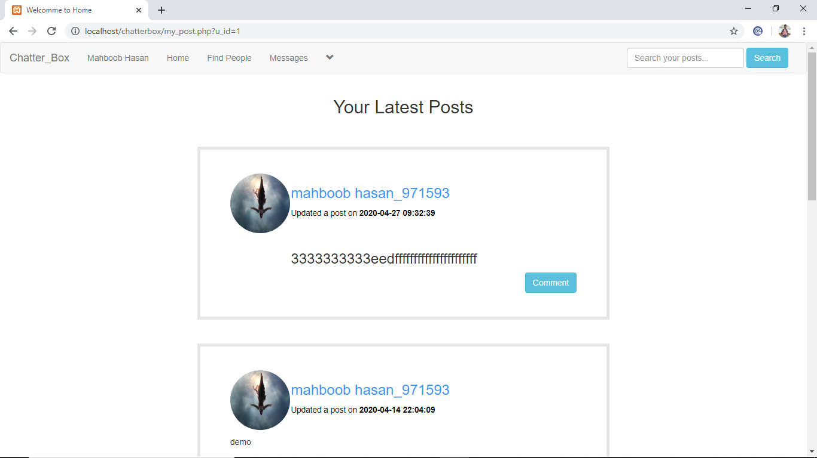

<!DOCTYPE html>

<?php

session_start();

include("includes/header.php");

?>

<?php

if(!isset($_SESSION['user_email'])){

header("location: index.php");

}

else{ ?>

<html>

<head>

<title>Welcomme to Home</title>

<meta charset="utf-8">

<meta name="viewport" content="width=device-width, initial-scale=1">

<link rel="stylesheet" href="https://maxcdn.bootstrapcdn.com/bootstrap/3.3.7/css/bootstrap.min.css">

<script src="https://ajax.googleapis.com/ajax/libs/jquery/3.3.1/jquery.min.js"></script>

<script src="https://maxcdn.bootstrapcdn.com/bootstrap/3.3.7/js/bootstrap.min.js"></script>

<link rel="stylesheet" href="styles/home_style2.css" media="all"/>

</head>

<body>

<div class="row">

<div class="col-sm-12">

<center><h2>Your Latest Posts</h2></center><br><br>

<?php user_posts();?>

</div>

</div>

</body>

</html>

<?php } ?>

**Edit Profile**

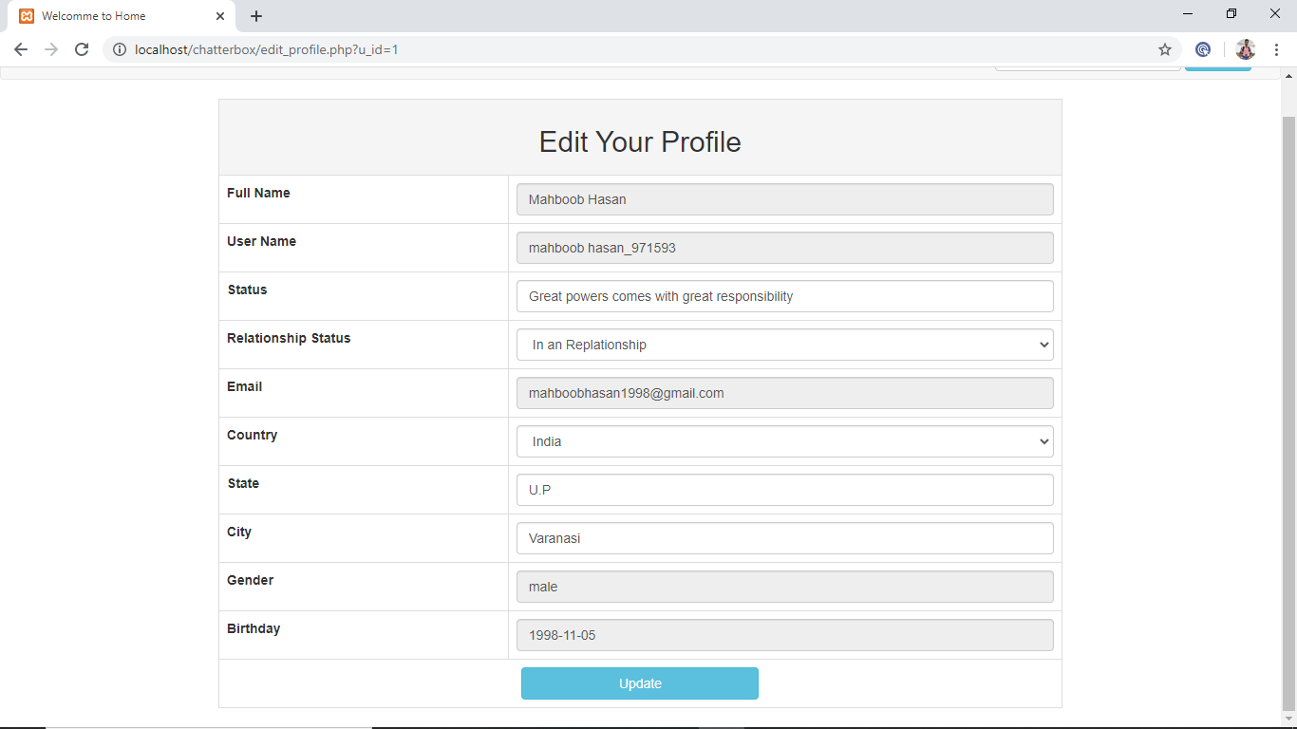

<!DOCTYPE html>

<?php

session_start();

include("includes/header.php");

?>

<?php

if(!isset($_SESSION['user_email'])){

header("location: index.php");

}

else{ ?>

<html>

<head>

<title>Welcomme to Home</title>

<meta charset="utf-8">

<meta name="viewport" content="width=device-width, initial-scale=1">

<link rel="stylesheet" href="https://maxcdn.bootstrapcdn.com/bootstrap/3.3.7/css/bootstrap.min.css">

<script src="https://ajax.googleapis.com/ajax/libs/jquery/3.3.1/jquery.min.js"></script>

<script src="https://maxcdn.bootstrapcdn.com/bootstrap/3.3.7/js/bootstrap.min.js"></script>

<link rel="stylesheet" href="styles/home_style2.css" media="all"/>

</head>

<style>

</style>

<body>

<div class="row">

<div class="col-sm-3">

</div>

<div class="col-sm-6">

<?php

if(isset($_GET['post_id'])){

$get_id = $_GET['post_id'];

$get_post = "select * from posts where post_id='$get_id'";

$run_post = mysqli_query($con,$get_post);

$row=mysqli_fetch_array($run_post);

$post_con = $row['post_content'];

}

?>

<form action="" method="post" id="f"><br>

<center><h2>Edit Your Post:</h2></center><br>

<textarea class="form-control" cols="83" rows="4" name="content"><?php echo $post_con;?></textarea><br>

<input type="submit" name="update" value="Update Post" class="btn btn-info"/>

</form>

<?php

if(isset($_POST['update'])){

$content = $_POST['content'];

$update_post = "update posts set post_content='$content' where post_id='$get_id'";

$run_update = mysqli_query($con,$update_post);

if($run_update){

echo "<script>alert('Post has been updated!')</script>";

echo "<script>window.open('home.php','_self')</script>";

}}?>

</div>

<div class="col-sm-3">

</div>

</div>

</body>

</html>

<?php } ?>

**Forgot Password**

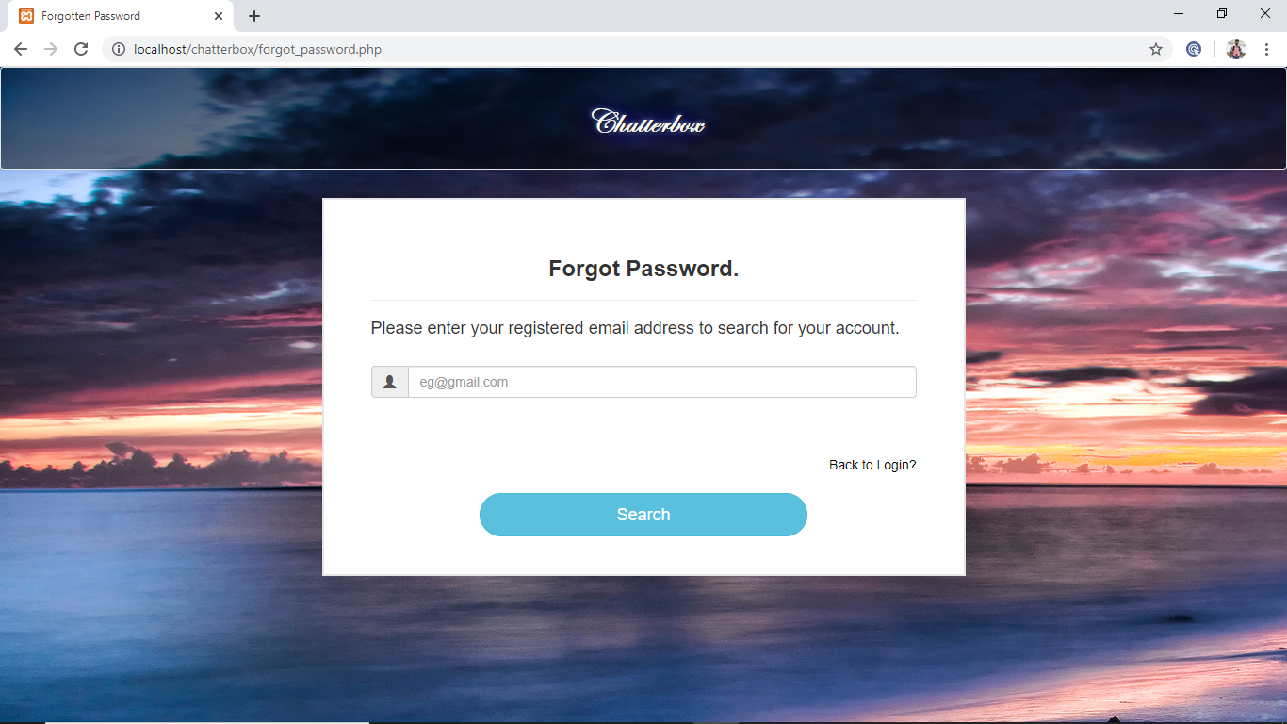

<!DOCTYPE html>

<html>

<head>

<title>Forgotten Password</title>

<meta charset="utf-8">

<meta name="viewport" content="width=device-width, initial-scale=1">

<link rel="stylesheet" href="https://maxcdn.bootstrapcdn.com/bootstrap/3.3.7/css/bootstrap.min.css">

<script src="https://ajax.googleapis.com/ajax/libs/jquery/3.3.1/jquery.min.js"></script>

<script src="https://maxcdn.bootstrapcdn.com/bootstrap/3.3.7/js/bootstrap.min.js"></script>

<script src="jquery.js"></script>

</head>

<style>

body{

overflow-x: hidden;

}

.main-content {

width: 50%;

height: 40%;

margin: 10px auto;

background-color: #fff;

border: 2px solid #e6e6e6;

padding: 40px 50px;

}

.header {

border: 0px solid #000;

margin-bottom: 5px;

}

.well{

background:rgba(0,0,0,0.5);

font-weight: 800;

font-size: 35px;

font-family:Edwardian Script ITC;

color: white;

text-shadow: 1px 1px 2px black, 0 0 25px blue, 0 0 5px lightblue;

}

#signup{

width: 60%;

border-radius: 30px;

}

</style>

<body background="images/12.jpg">

<div class="row">

<div class="col-sm-12">

<div class="well">

<center><h1><strong>Chatterbox</strong></h1></center>

</div>

</div>

</div>

<div class="row">

<div class="col-sm-12">

<div class="main-content">

<div class="header">

<h3 style="text-align: center;"><strong>Forgot Password.</strong></h3><hr>

</div>

<div class="l-part">

<form action="" method="post">

<h4>Please enter your registered email address to search for your account.</h4>

<br>

<div class="input-group">

<span class="input-group-addon"><i class="glyphicon glyphicon-user"></i></span>

<input id="email" type="text" class="form-control" name="email" placeholder="eg@gmail.com" required="required" autocomplete="off">

</div><br>

<hr>

<a style="text-decoration:none; float: right;color:black;" title="Signin" href="index.php">Back to Login?</a><br><br>

<center><button id="signup" class="btn btn-info btn-lg" name="submit">Search</button></center>

</form>

</div>

</div>

</div>

</div>

</body>

</html>

<?php

session_start();

include("includes/connection.php");

if(isset($_POST['submit'])){

$email = htmlentities(mysqli_real_escape_string($con,$_POST['email']));

$select_user = "select * from users where user_email='$email'";

$query = mysqli_query($con,$select_user);

$check_user = mysqli_num_rows($query);

if($check_user==1){

$_SESSION['user_email']=$email;

echo "<script>window.open('security.php','_self')</script>";

}

else {

echo "<script>alert('Your Email or your Bestfriend name is Incorrect')</script>";

echo "<script>window.open('forgot_password.php','_self')</script>";

}}?>

**Verifying User**

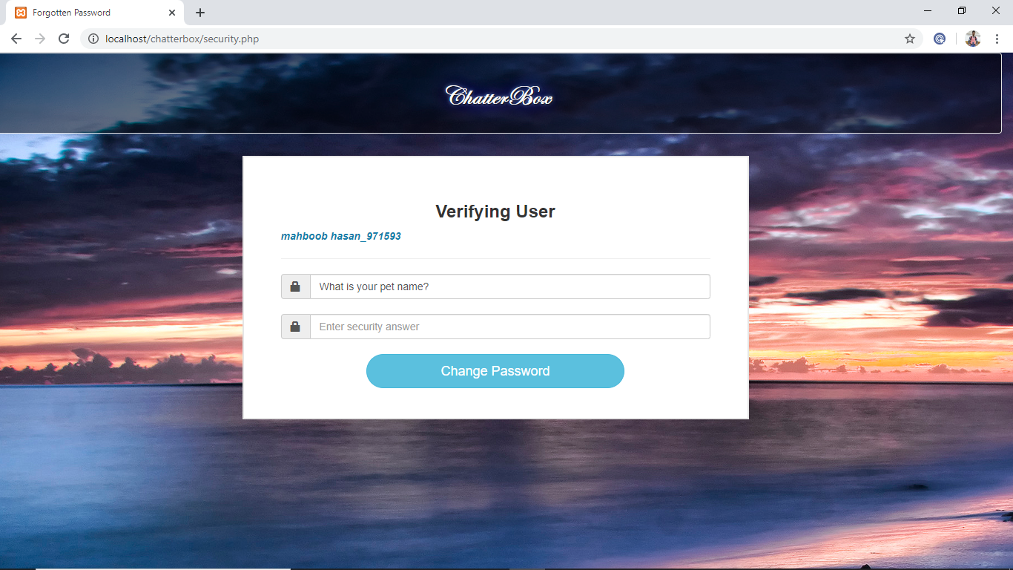

<!DOCTYPE html>

<?php

session_start();

include("includes/connection.php");

include("functions/functions.php");

?>

<?php

if(!isset($_SESSION['user_email'])){

header("location: index.php");

}else{

?>

<!DOCTYPE html>

<html>

<head>

<title>Forgotten Password</title>

<meta charset="utf-8">

<meta name="viewport" content="width=device-width, initial-scale=1">

<link rel="stylesheet" href="https://maxcdn.bootstrapcdn.com/bootstrap/3.3.7/css/bootstrap.min.css">

<script src="https://ajax.googleapis.com/ajax/libs/jquery/3.3.1/jquery.min.js"></script>

<script src="https://maxcdn.bootstrapcdn.com/bootstrap/3.3.7/js/bootstrap.min.js"></script>

<script src="jquery.js"></script>

</head>

<style>

body{

overflow-x: hidden;

}

.main-content {

width: 50%;

height: 40%;

margin: 10px auto;

background-color: #fff;

border: 2px solid #e6e6e6;

padding: 40px 50px;

}

.header {

border: 0px solid #000;

margin-bottom: 5px;

}

.well{

background:rgba(0,0,0,0.5);

font-weight: 800;

font-size: 35px;

font-family:Edwardian Script ITC;

color: white;

text-shadow: 1px 1px 2px black, 0 0 25px blue, 0 0 5px lightblue;

}

#signup{

width: 60%;

border-radius: 30px;

}

</style>

<body background="images/12.jpg">

<div>

<?php

$user = $_SESSION['user_email'];

$get_user = "select * from users where user_email='$user'";

$run_user = mysqli_query($con,$get_user);

$row=mysqli_fetch_array($run_user);

$user_id = $row['user_id'];

$user_name = $row['user_name'];

$sec_que = $row['sec_que'];

?>

</div>

<div class="row">

<div class="col-sm-12">

<div class="well">

<center><h1 style="color: white;"><strong>ChatterBox</strong></h1></center>

</div>

</div>

</div>

<div class="row">

<div class="col-sm-12">

<div class="main-content">

<div class="header">

<h3 style="text-align: center;"><strong>Change Your Password </strong></h3>

<strong style="color:#187FAB; "><i><?php echo $user_name; ?></i></strong>

<hr>

</div>

<div class="l-part">

<form action="" method="post">

<div class="input-group">

<span class="input-group-addon"><i class="glyphicon glyphicon-lock"></i></span>

<input id="text" type="text" class="form-control" value="<?php echo $sec_que; ?>">

</div><br>

<div class="input-group">

<span class="input-group-addon"><i class="glyphicon glyphicon-lock"></i></span>

<input id="password" type="text" class="form-control" name="ans" placeholder="Enter security answer" required="required">

</div><br>

<center><button id="signup" class="btn btn-info btn-lg" name="s_change">Change Password</button></center>

</form>

</div>

</div>

</div>

</div>

</body>

</html>

<?php

if(isset($_POST['s_change'])){

$sec_ans = htmlentities(mysqli_real_escape_string($con,$_POST['ans']));

$select_user = "select * from users where sec_ans='$sec_ans'";

$query = mysqli_query($con,$select_user);

$check_user = mysqli_num_rows($query);

if($check_user==1){

$_SESSION['sec_ans']=$sec_ans;

echo "<script>window.open('change_password.php','_self')</script>";

}

else {

echo "<script>alert('Your Email or your Bestfriend name is Incorrect')</script>";

echo "<script>window.open('security.php','_self')</script>";

}

}

}

?>

**Change Password**

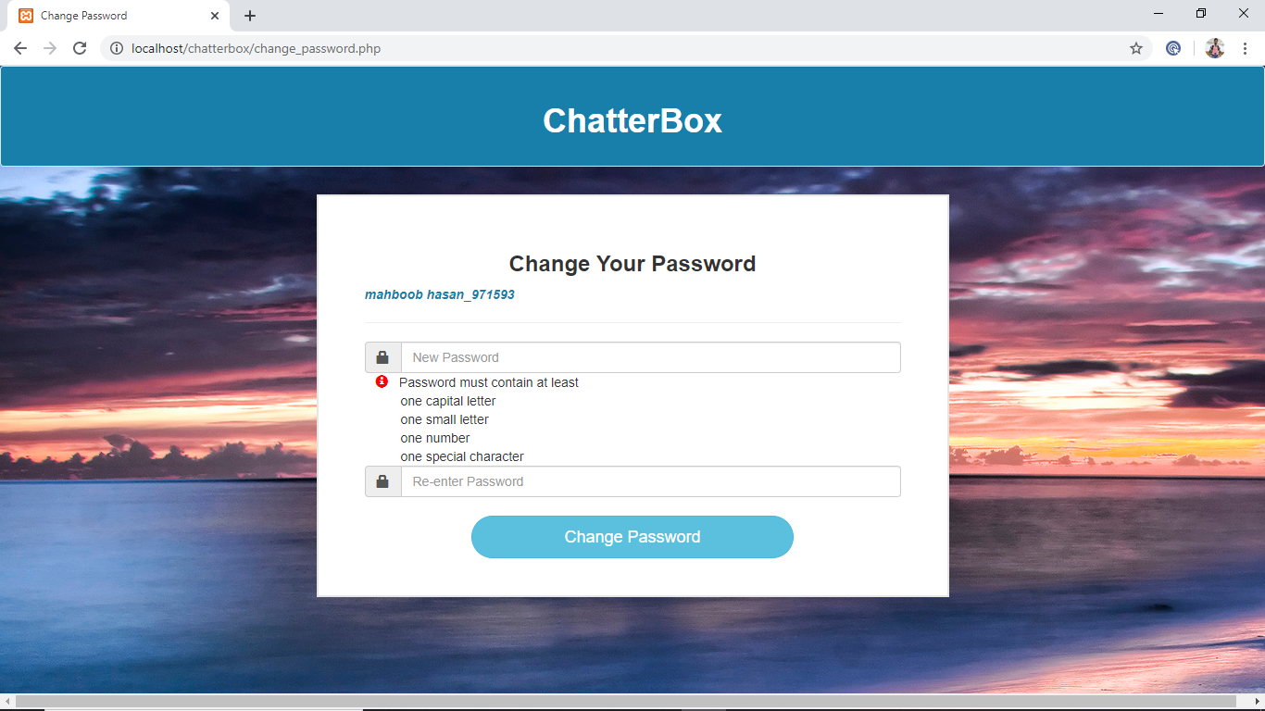

<!DOCTYPE html>

<?php

session_start();

include("includes/connection.php");

include("functions/functions.php");

?>

<?php

if(!isset($_SESSION['user_email'])){

header("location: index.php");

}else{

?>

<!DOCTYPE html>

<html>

<head>

<title>Change Password</title>

<link rel="stylesheet" type="text/css" href="styles/forgot_password.css">

<meta charset="utf-8">

<meta name="viewport" content="width=device-width, initial-scale=1">

<link rel="stylesheet" href="https://maxcdn.bootstrapcdn.com/bootstrap/3.3.7/css/bootstrap.min.css">

<script src="https://ajax.googleapis.com/ajax/libs/jquery/3.3.1/jquery.min.js"></script>

<script src="https://maxcdn.bootstrapcdn.com/bootstrap/3.3.7/js/bootstrap.min.js"></script>

</head>

<style>

.main-content {

width: 50%;

height: 40%;

margin: 10px auto;

background-color: #fff;

border: 2px solid #e6e6e6;

padding: 40px 50px;

}

.header {

border: 0px solid #000;

margin-bottom: 5px;

}

.well{

background-color: #187FAB;

}

#signup{

width: 60%;

border-radius: 30px;

}

</style>

<body background="images/12.jpg">

<div>

<?php

$user = $_SESSION['user_email'];

$get_user = "select * from users where user_email='$user'";

$run_user = mysqli_query($con,$get_user);

$row=mysqli_fetch_array($run_user);

$user_id = $row['user_id'];

$user_name = $row['user_name'];

?>

</div>

<div class="row">

<div class="col-sm-12">

<div class="well">

<center><h1 style="color: white;"><strong>ChatterBox</strong></h1></center>

</div>

</div>

</div>

<div class="row">

<div class="col-sm-12">

<div class="main-content">

<div class="header">

<h3 style="text-align: center;"><strong>Change Your Password </strong></h3>

<strong style="color:#187FAB; "><i><?php echo $user_name; ?></i></strong>

<hr>

</div>

<div class="l-part">

<form action="" method="post">

<div class="input-group">

<span class="input-group-addon"><i class="glyphicon glyphicon-lock"></i></span>

<input id="password" type="password" class="form-control" name="pass" placeholder="New Password" required="required">

</div>&nbsp&nbsp&nbsp<i class="glyphicon glyphicon-info-sign" style="color:red;"></i>&nbsp&nbsp

Password must contain at least<br>

&nbsp&nbsp&nbsp&nbsp&nbsp&nbsp&nbsp&nbsp&nbsp one capital letter<br>

&nbsp&nbsp&nbsp&nbsp&nbsp&nbsp&nbsp&nbsp&nbsp one small letter<br>

&nbsp&nbsp&nbsp&nbsp&nbsp&nbsp&nbsp&nbsp&nbsp one number<br>

&nbsp&nbsp&nbsp&nbsp&nbsp&nbsp&nbsp&nbsp&nbsp one special character<br>

<div class="input-group">

<span class="input-group-addon"><i class="glyphicon glyphicon-lock"></i></span>

<input id="password" type="password" class="form-control" name="pass1" placeholder="Re-enter Password" required="required">

</div><br>

<center><button id="signup" class="btn btn-info btn-lg" name="change">Change Password</button></center>

</form>

</div>

</div>

</div>

</div>

</body>

</html>

<?php

if(isset($_POST['change'])){

$pass = htmlentities(mysqli_real_escape_string($con,$_POST['pass']));

$pass1 = htmlentities(mysqli_real_escape_string($con,$_POST['pass1']));

if ($pass == $pass1) {

$p = password_hash($pass, PASSWORD_DEFAULT);

$p1 = password_hash($pass1, PASSWORD_DEFAULT);

if (strlen($pass) >= 6 && strlen($pass) <= 60) {

$update = "update users set user_pass='$p' where user_id='$user_id'";

$run = mysqli_query($con,$update);

echo "<script>alert('Your Password is changed a moment ago')</script>";

echo "<script>window.open('home.php','_self')</script>";

}else{

echo "<script>alert('Your Password should be greater than 6 words')</script>";

}

}else{

echo "<script>alert('Your Passwords did not match')</script>";

echo "<script>window.open('change_password.php','_self')</script>";

}} ?>

<?php } ?>

**Edit Post**

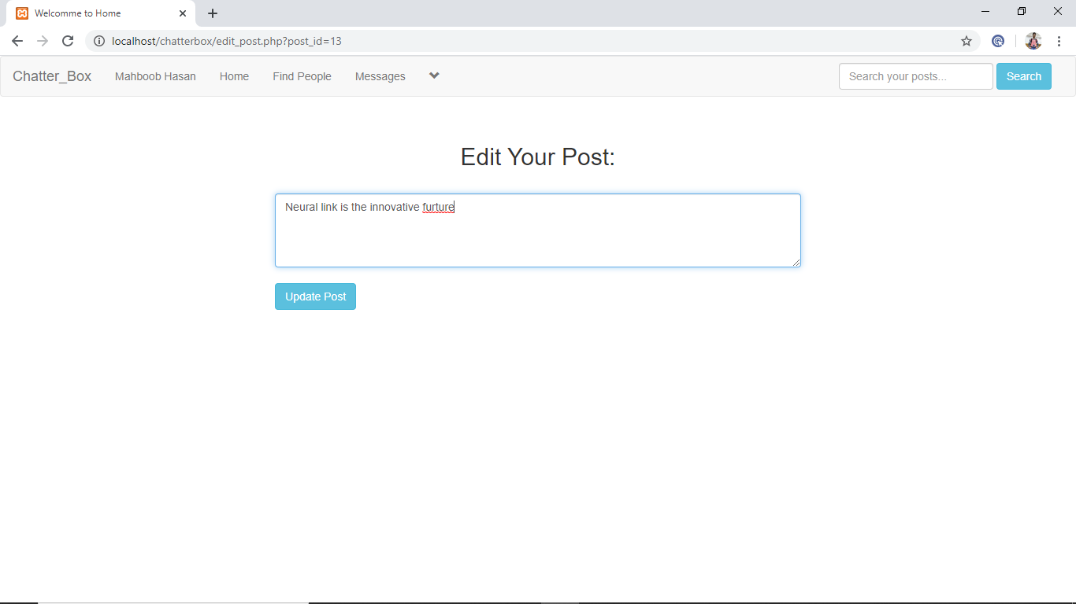

<!DOCTYPE html>

<?php

session_start();

include("includes/header.php");

?>

<?php

if(!isset($_SESSION['user_email'])){

header("location: index.php");

}

else{ ?>

<html>

<head>

<title>Welcomme to Home</title>

<meta charset="utf-8">

<meta name="viewport" content="width=device-width, initial-scale=1">

<link rel="stylesheet" href="https://maxcdn.bootstrapcdn.com/bootstrap/3.3.7/css/bootstrap.min.css">

<script src="https://ajax.googleapis.com/ajax/libs/jquery/3.3.1/jquery.min.js"></script>

<script src="https://maxcdn.bootstrapcdn.com/bootstrap/3.3.7/js/bootstrap.min.js"></script>

<link rel="stylesheet" href="styles/home_style2.css" media="all"/>

</head>

<style>

</style>

<body>

<div class="row">

<div class="col-sm-3">

</div>

<div class="col-sm-6">

<?php

if(isset($_GET['post_id'])){

$get_id = $_GET['post_id'];

$get_post = "select * from posts where post_id='$get_id'";

$run_post = mysqli_query($con,$get_post);

$row=mysqli_fetch_array($run_post);

$post_con = $row['post_content'];

}

?>

<form action="" method="post" id="f"><br>

<center><h2>Edit Your Post:</h2></center><br>

<textarea class="form-control" cols="83" rows="4" name="content"><?php echo $post_con;?></textarea><br>

<input type="submit" name="update" value="Update Post" class="btn btn-info"/>

</form>

<?php

if(isset($_POST['update'])){

$content = $_POST['content'];

$update_post = "update posts set post_content='$content' where post_id='$get_id'";

$run_update = mysqli_query($con,$update_post);

if($run_update)

echo "<script>alert('Post has been updated!')</script>";

echo "<script>window.open('home.php','_self')</script>";

}}?>

</div>

<div class="col-sm-3">

</div></div>

</body>

</html>

<?php } ?>

**Friends Profile**

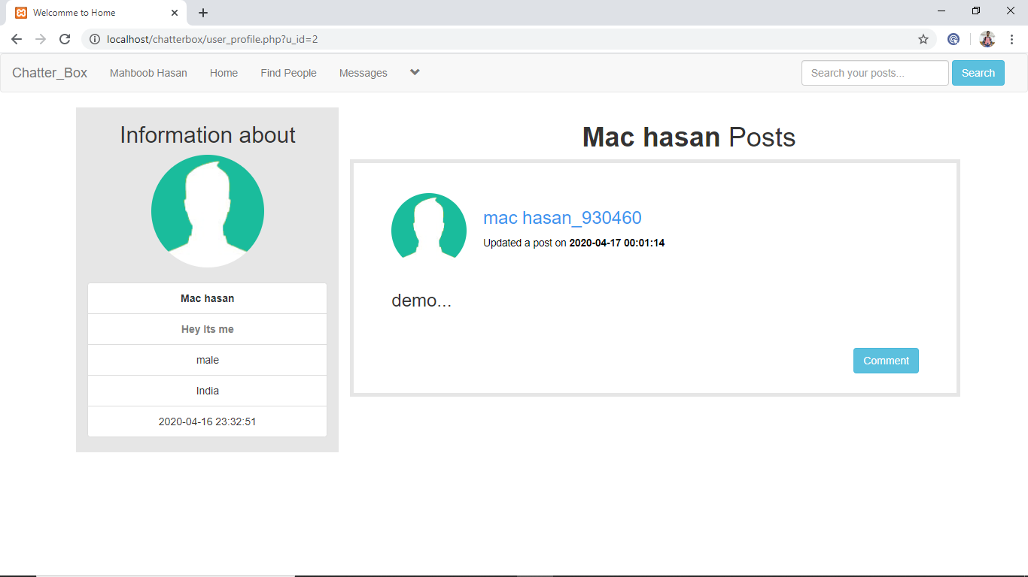

<!DOCTYPE html>

<?php

session_start();

include("includes/header.php");

?>

<?php

if(!isset($_SESSION['user_email'])){

header("location: index.php");

}

else{ ?>

<html>

<head>

<title>Welcomme to Home</title>

<meta charset="utf-8">

<meta name="viewport" content="width=device-width, initial-scale=1">

<link rel="stylesheet" href="https://maxcdn.bootstrapcdn.com/bootstrap/3.3.7/css/bootstrap.min.css">

<script src="https://ajax.googleapis.com/ajax/libs/jquery/3.3.1/jquery.min.js"></script>

<script src="https://maxcdn.bootstrapcdn.com/bootstrap/3.3.7/js/bootstrap.min.js"></script>

<link rel="stylesheet" href="styles/home_style2.css" media="all"/>

</head>

<style>

#own_posts

{

border: 5px solid #e6e6e6;

padding: 40px 50px;

width:90%;

}

#posts_img

{

height:300px;

width:100%;

}

</style>

<body>

<div class="row">

<?php

global $con;

if(isset($_GET['u_id'])){

$u_id = $_GET['u_id'];

}

if($u_id < 0 OR $u_id == ""){

echo"<script>window.open('home.php','_self')</script>";

}else{ ?>

<div class="col-sm-12">

<?php

if(isset($_GET['u_id'])){

global $con;

$user_id = $_GET['u_id'];

$select = "select * from users where user_id='$user_id'";

$run = mysqli_query($con,$select);

$row=mysqli_fetch_array($run);

$name = $row['user_name'];

} ?>

<?php

if(isset($_GET['u_id'])){

global $con;

$user_id = $_GET['u_id'];

$select = "select * from users where user_id='$user_id'";

$run = mysqli_query($con,$select);

$row=mysqli_fetch_array($run);

$id = $row['user_id'];

$image = $row['user_image'];

$name = $row['user_name'];

$f_name = $row['fullname'];

$describe_user = $row['describe_user'];

$country = $row['user_country'];

$gender = $row['user_gender'];

$register_date = $row['user_reg_date'];

echo "

<div class='row'>

<div class='col-sm-1'>

</div>

<center>

<div style='background-color: #e6e6e6;' class='col-sm-3'>

<h2>Information about</h2>

<img class='img-circle' src='users/$image' width='150' height='150' />

<br>

<br>

<ul class='list-group'>

<li class='list-group-item' title='Username'><strong>$f_name</strong></li>

<li class='list-group-item' title='User Status'><strong style='color:grey;'>$describe_user</strong></li>

<li class='list-group-item' title='Gender'>$gender</li>

<li class='list-group-item' title='Country'>$user_country</li>

<li class='list-group-item' title='User Registration Date'>$register_date</li>

</ul> ";

$user = $_SESSION['user_email'];

$get_user = "select * from users where user_email='$user'";

$run_user = mysqli_query($con,$get_user);

$row=mysqli_fetch_array($run_user);

$userown_id = $row['user_id'];

$user_name = $row['user_name'];

$user_image = $row['user_image'];

if($user_id == $userown_id){

echo"<a href='edit_profile.php?u_id=$userown_id' class='btn btn-success'/>Edit Profile</a><br><br><br>";

}

echo"

</div>

</center>

"; } ?>

<div class='col-sm-8'>

<center><h1><strong><?php echo "$f_name"; ?></strong> Posts</h1></center>

<?php

global $con;

if(isset($_GET['u_id'])){

$u_id = $_GET['u_id'];

}

$get_posts = "select * from posts where user_id='$u_id' ORDER by 1 DESC LIMIT 5";

$run_posts = mysqli_query($con,$get_posts);

while($row_posts=mysqli_fetch_array($run_posts)){

$post_id = $row_posts['post_id'];

$user_id = $row_posts['user_id'];

$content = $row_posts['post_content'];

$upload_image = $row_posts['upload_image'];

$post_date = $row_posts['post_date'];

$user = "select * from users where user_id='$user_id' AND posts='yes'";

$run_user = mysqli_query($con,$user);

$row_user=mysqli_fetch_array($run_user);

$user_name = $row_user['user_name'];

$f_name = $row['fullname'];

$user_image = $row_user['user_image'];

if($content=="No" && strlen($upload_image) >= 1){

echo "

<div id='own_posts'>

<div class='row'>

<div class='col-sm-2'>

<p><img src='users/$user_image' class='img-circle' width='100px' height='100px'></p>

</div>

<div class='col-sm-6'>

<h3><a style='text-decoration: none;cursor: pointer;color: #3897f0;' href='user_profile.php?u_id=$user_id'>$user_name</a></h3>

<h4><small style='color:black;'>Updated a post on <strong>$post_date</strong></small></h4>

</div>

<div class='col-sm-4'>

</div>

</div>

<div class='row'>

<div class='col-sm-12'>

<img id='posts-img' src='imagepost/$upload_image' style='height:350px;'>

</div>

</div>

<br>

<a href='single.php?post_id=$post_id' style='float:right;'><button class='btn btn-success'>View</button></a>

<a href='functions/delete_post.php?post_id=$post_id' style='float:right;'><button class='btn btn-danger'>Delete</button></a>

</div>

<br/>

<br/> "; }

else if(strlen($content) >= 1 && strlen($upload_image) >= 1){

echo "

<div id='own_posts'>

<div class='row'>

<div class='col-sm-2'>

<p><img src='users/$user_image' class='img-circle' width='100px' height='100px'></p>

</div>

<div class='col-sm-6'>

<h3>

<a style='text-decoration: none;cursor: pointer;color: #3897f0;' href='user_profile.php?u_id=$user_id'>$user_name</a></h3>

<h4><small style='color:black;'>Updated a post on <strong>$post_date</strong></small></h4>

</div>

<div class='col-sm-4'>

</div>

</div>

<div class='row'>

<div class='col-sm-12'>

<p>$content</p>

<img id='posts-img' src='imagepost/$upload_image' style='height:350px;'>

</div>

</div>

<br>

<a href='single.php?post_id=$post_id' style='float:right;'><button class='btn btn-success'>View</button></a>

<a href='functions/delete_post.php?post_id=$post_id' style='float:right;'><button class='btn btn-danger'>Delete</button></a>

</div><br/><br/> ";}

else{

echo "

<div id='own_posts'>

<div class='row'>

<div class='col-sm-2'>

<p><img src='users/$user_image' class='img-circle' width='100px' height='100px'></p>

</div>

<div class='col-sm-6'>

<h3><a style='text-decoration: none;cursor: pointer;color: #3897f0;' href='user_profile.php?u_id=$user_id'>$user_name</a></h3>

<h4><small style='color:black;'>Updated a post on <strong>$post_date</strong></small></h4>

</div>

<div class='col-sm-4'>

</div>

</div>

<div class='row'>

<div class='col-sm-12'>

<h3><p>$content...</p></h3><br>

</div>

</div>

<br>

<a href='single.php?post_id=$post_id' style='float:right;'><button class='btn btn-info'>Comment</button></a><br>

</div>

<br>

<br>

";} } ?>

</div>

</div>

</div>

<?php } //else hehe ends ?>

</body>

</html>

<?php } ?>

**Comment**

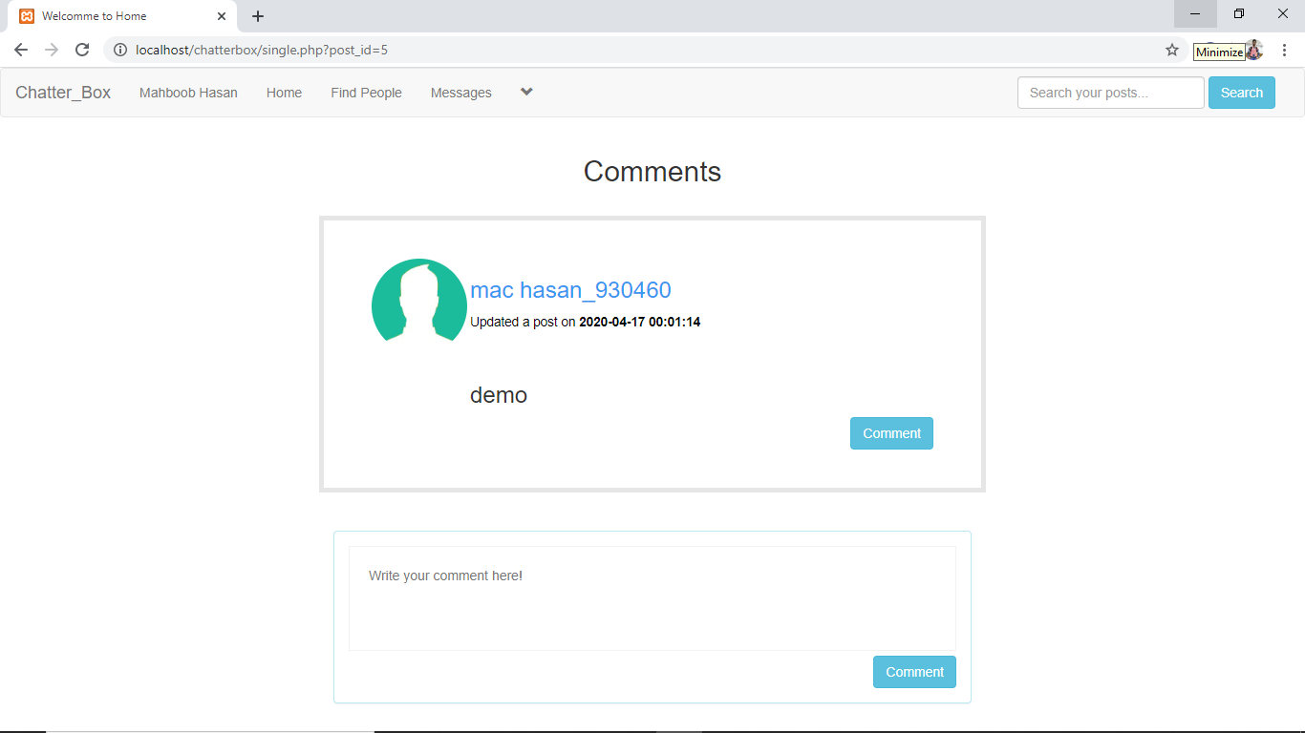

<!DOCTYPE html>

<?php

session_start();

include("includes/header.php");

?>

<?php

if(!isset($_SESSION['user_email'])){

header("location: index.php");

}

else{ ?>

<html>

<head>

<title>Welcomme to Home</title>

<meta charset="utf-8">

<meta name="viewport" content="width=device-width, initial-scale=1">

<link rel="stylesheet" href="https://maxcdn.bootstrapcdn.com/bootstrap/3.3.7/css/bootstrap.min.css">

<script src="https://ajax.googleapis.com/ajax/libs/jquery/3.3.1/jquery.min.js"></script>

<script src="https://maxcdn.bootstrapcdn.com/bootstrap/3.3.7/js/bootstrap.min.js"></script>

<link rel="stylesheet" href="styles/home_style2.css" media="all"/>

</head>

<body>

<div class="row">

<div class="col-sm-12">

<center><h2>Comments</h2><br></center>

<?php single_post();?>

</div>

</div>

</body>

</html>

<?php } ?>

**Search Friends Posts**

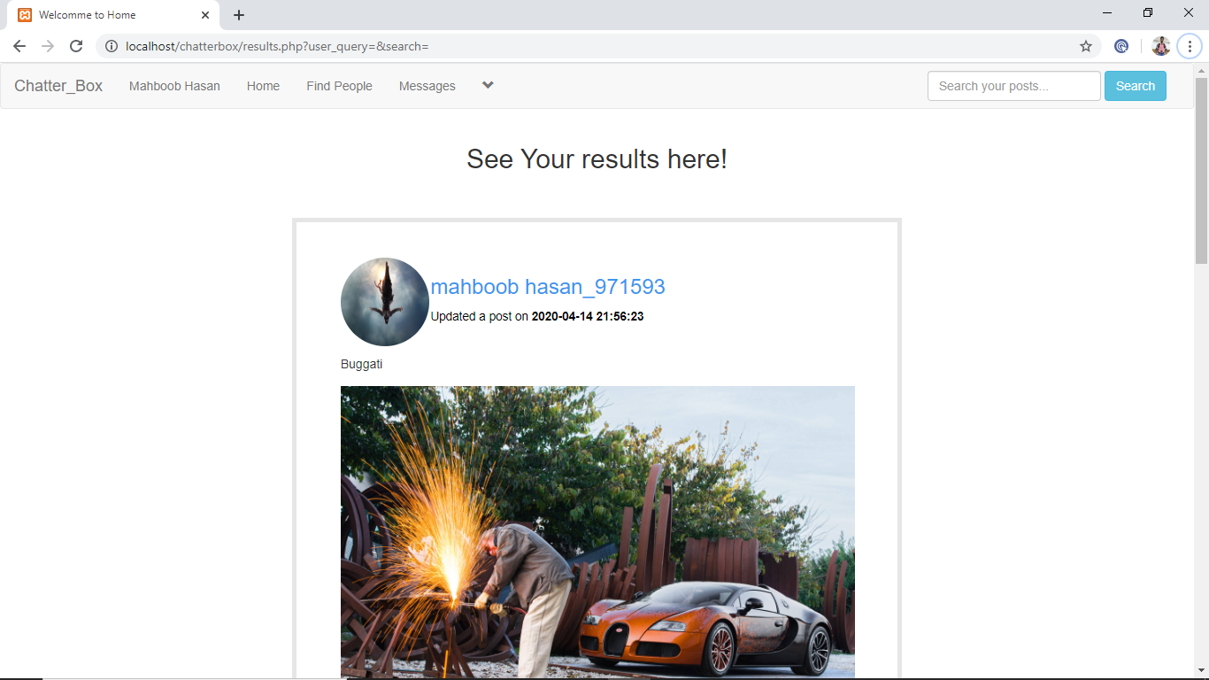

<!DOCTYPE html>

<?php

session_start();

include("includes/header.php");

?>

<?php

if(!isset($_SESSION['user_email'])){

header("location: index.php");

}

else{ ?>

<html>

<head>

<title>Welcomme to Home</title>

<meta charset="utf-8">

<meta name="viewport" content="width=device-width, initial-scale=1">

<link rel="stylesheet" href="https://maxcdn.bootstrapcdn.com/bootstrap/3.3.7/css/bootstrap.min.css">

<script src="https://ajax.googleapis.com/ajax/libs/jquery/3.3.1/jquery.min.js"></script>

<script src="https://maxcdn.bootstrapcdn.com/bootstrap/3.3.7/js/bootstrap.min.js"></script>

<link rel="stylesheet" href="styles/home_style2.css" media="all"/>

</head>

<body>

<div class="row">

<div class="col-sm-12">

<center><h2>See Your results here!</h2></center><br><br>

<?php results();?>

</div>

</div>

</body>

</html>

<?php } ?>

<?php

$con = mysqli_connect("localhost","root","","chatterbox") or die("Connection was not established");

function insertPost(){

if(isset($_POST['sub'])){

global $con;

global $user_id;

$content = htmlentities($_POST['content']);

$upload_image = $_FILES['upload_image']['name'];

$image_tmp = $_FILES['upload_image']['tmp_name'];

$random_number = rand(1,100);

if(strlen($content) > 250){

echo "<script>alert('Please Use 250 or less than 250 words')</script>";

echo"<script>window.open('home.php','_self')</script>";

}else{

if(strlen($upload_image) >= 1 && strlen($content) >= 1){

move_uploaded_file($image_tmp,"imagepost/$upload_image.$random_number");

$insert = "insert into posts (user_id,post_content,upload_image,post_date) values ('$user_id','$content','$upload_image.$random_number',NOW())";

$run = mysqli_query($con,$insert);

if($run){

echo "<script>alert('Your Post Have Been Updated Successfully.')</script>";

echo"<script>window.open('home.php','_self')</script>";

$update = "update users set posts='yes' where user_id='$user_id'";

$run_update = mysqli_query($con,$update);

}

exit();

}else{

if($upload_image == '' && $content == ''){

echo "<script>alert('Error Occured while uploading!')</script>";

echo"<script>window.open('home.php','_self')</script>";

}else{

if($content==''){

move_uploaded_file($image_tmp,"imagepost/$upload_image.$random_number");

$insert = "insert into posts (user_id,post_content,upload_image,post_date) values ('$user_id','No','$upload_image.$random_number',NOW())";

$run = mysqli_query($con,$insert);

if($run){

echo "<script>alert('Your Post Have Been Updated Successfully.')</script>";

echo"<script>window.open('home.php','_self')</script>";

$update = "update users set posts='yes' where user_id='$user_id'";

$run_update = mysqli_query($con,$update);

}

exit();}

else {

$insert = "insert into posts (user_id,post_content,post_date) values ('$user_id','$content',NOW())";

$run = mysqli_query($con,$insert);

if($run){

echo "<script>alert('Your Post Have Been Updated Successfully.')</script>";

echo"<script>window.open('home.php','_self')</script>";

$update = "update users set posts='yes' where user_id='$user_id'";

$run_update = mysqli_query($con,$update);

}}}}}}}

function get_posts(){

global $con;

$per_page=4;

if (isset($_GET['page'])) {

$page = $_GET['page'];

}

else {

$page=1;

}

$start_from = ($page-1) * $per_page;

$get_posts = "select * from posts ORDER by 1 DESC LIMIT $start_from, $per_page";

$run_posts = mysqli_query($con,$get_posts);

while($row_posts=mysqli_fetch_array($run_posts)){

$post_id = $row_posts['post_id'];

$user_id = $row_posts['user_id'];

$content = substr($row_posts['post_content'],0,40);

$upload_image = $row_posts['upload_image'];

$post_date = $row_posts['post_date'];

$user = "select * from users where user_id='$user_id' AND posts='yes'";

$run_user = mysqli_query($con,$user);

$row_user=mysqli_fetch_array($run_user);

$user_name = $row_user['user_name'];

$user_image = $row_user['user_image'];

if($content=="No" && strlen($upload_image) >= 1){

echo "

<div class='row'>

<div class='col-sm-3'>

</div>

<div id='posts' class='col-sm-6'>

<div class='row'>

<div class='col-sm-2'>

<p><img src='users/$user_image' class='img-circle' width='100px' height='100px'></p>

</div>

<div class='col-sm-6'>

<h3><a style='text-decoration: none;cursor: pointer;color: #3897f0;' href='user_profile.php?u_id=$user_id'>$user_name</a></h3>

<h4><small style='color:black;'>Updated a post on <strong>$post_date</strong></small></h4>

</div>

<div class='col-sm-4'>

</div>

</div>

<div class='row'>

<div class='col-sm-1'></div>

<div class='col-sm-10'>

<img id='posts-img' src='imagepost/$upload_image' style='height:450px;'>

</div>

</div><br>

<a href='single.php?post_id=$post_id' style='float:right;'><button class='btn btn-info'>Comment</button></a><br>

</div>

<div class='col-sm-3'>

</div>

</div><br><br>"; }

else if(strlen($content) >= 1 && strlen($upload_image) >= 1){

echo "

<div class='row'>

<div class='col-sm-3'>

</div>

<div id='posts' class='col-sm-6'>

<div class='row'>

<div class='col-sm-2'>

<p><img src='users/$user_image' class='img-circle' width='100px' height='100px'></p>

</div>

<div class='col-sm-6'>

<h3><a style='text-decoration: none;cursor: pointer;color: #3897f0;' href='user_profile.php?u_id=$user_id'>$user_name</a></h3>

<h4><small style='color:black;'>Updated a post on <strong>$post_date</strong></small></h4>

</div>

<div class='col-sm-4'>

</div>

</div>

<div class='row'>

<div class='col-sm-12'>

<p>$content</p>

<img id='posts-img' src='imagepost/$upload_image' style='height:350px;'>

</div>

</div><br>

<a href='single.php?post_id=$post_id' style='float:right;'><button class='btn btn-info'>Comment</button></a><br>

</div>

<div class='col-sm-3'>

</div>

</div><br><br>;}

else{

echo "

<div class='row'>

<div class='col-sm-3'>

</div>

<div id='posts' class='col-sm-6'>

<div class='row'>

<div class='col-sm-2'>

<p><img src='users/$user_image' class='img-circle' width='100px' height='100px'></p>

</div>

<div class='col-sm-6'>

<h3><a style='text-decoration: none;cursor: pointer;color: #3897f0;' href='user_profile.php?u_id=$user_id'>$user_name</a></h3>

<h4><small style='color:black;'>Updated a post on <strong>$post_date</strong></small></h4>

</div>

<div class='col-sm-4'>

</div>

</div>

<div class='row'>

<div class='col-sm-2'>

</div>

<div class='col-sm-6'>

<h3><p>$content</p></h3>

</div>

<div class='col-sm-4'>

</div>

</div>

<a href='single.php?post_id=$post_id' style='float:right;'><button class='btn btn-info'>Comment</button></a><br>

</div>

<div class='col-sm-3'>

</div>

</div><br><br>";} }

include("pagination.php");

}

function single_post(){

if(isset($_GET['post_id'])){

global $con;

$get_id = $_GET['post_id'];

$get_posts = "select * from posts where post_id='$get_id'";

$run_posts = mysqli_query($con,$get_posts);

$row_posts=mysqli_fetch_array($run_posts);

$post_id = $row_posts['post_id'];

$user_id = $row_posts['user_id'];

$content = $row_posts['post_content'];

$upload_image = $row_posts['upload_image'];

$post_date = $row_posts['post_date'];

$user = "select * from users where user_id='$user_id' AND posts='yes'";

$run_user = mysqli_query($con,$user);

$row_user=mysqli_fetch_array($run_user);

$user_name = $row_user['user_name'];

$user_image = $row_user['user_image'];

$user_com = $_SESSION['user_email'];

$get_com = "select * from users where user_email='$user_com'";

$run_com = mysqli_query($con,$get_com);

$row_com=mysqli_fetch_array($run_com);

$user_com_id = $row_com['user_id'];

$user_com_name = $row_com['user_name'];

if(isset($_GET['post_id'])){

$post_id = $_GET['post_id'];

}

$get_posts = "select post_id from users where post_id='$post_id'";

$run_user = mysqli_query($con,$get_posts);

$post_id = $_GET['post_id'];

$post = $_GET['post_id'];

$get_user = "select * from posts where post_id='$post'";

$run_user = mysqli_query($con,$get_user); $row=mysqli_fetch_array($run_user);

$p_id = $row['post_id'];

if($p_id != $post_id){

echo "<script>alert('ERROR')</script>";

echo "<script>window.open('home.php','_self')</script>";

}else{

if($content=="No" && strlen($upload_image) >= 1){

echo "

<div class='row'>

<div class='col-sm-3'>

</div>

<div id='posts' class='col-sm-6'>

<div class='row'>

<div class='col-sm-2'>

<p><img src='users/$user_image' class='img-circle' width='100px' height='100px'></p>

</div>

<div class='col-sm-6'>

<h3><a style='text-decoration: none;cursor: pointer;color: #3897f0;' href='user_profile.php?u_id=$user_id'>$user_name</a></h3>

<h4><small style='color:black;'>Updated a post on <strong>$post_date</strong></small></h4>

</div>

<div class='col-sm-4'>

</div>

</div>

<div class='row'>

<div class='col-sm-12'>

<img id='posts-img' src='imagepost/$upload_image' style='height:350px;'>

</div>

</div><br>

<a href='single.php?post_id=$post_id' style='float:right;'><button class='btn btn-info'>Comment</button></a><br>

</div>

<div class='col-sm-3'>

</div>

</div><br><br>

";}

else if(strlen($content) >= 1 && strlen($upload_image) >= 1){

echo "

<div class='row'>

<div class='col-sm-3'>

</div>

<div id='posts' class='col-sm-6'>

<div class='row'>

<div class='col-sm-2'>

<p><img src='users/$user_image' class='img-circle' width='100px' height='100px'></p>

</div>

<div class='col-sm-6'>

<h3><a style='text-decoration: none;cursor: pointer;color: #3897f0;' href='user_profile.php?u_id=$user_id'>$user_name</a></h3>

<h4><small style='color:black;'>Updated a post on <strong>$post_date</strong></small></h4>

</div>

<div class='col-sm-4'>

</div>

</div>

<div class='row'>

<div class='col-sm-12'>

<p>$content</p>

<img id='posts-img' src='imagepost/$upload_image' style='height:350px;'>

</div>

</div><br>

<a href='single.php?post_id=$post_id' style='float:right;'><button class='btn btn-info'>Comment</button></a><br>

</div>

<div class='col-sm-3'>

</div>

</div><br><br>"; }

else{

echo "

<div class='row'>

<div class='col-sm-3'>

</div>

<div id='posts' class='col-sm-6'>

<div class='row'>

<div class='col-sm-2'>

<p><img src='users/$user_image' class='img-circle' width='100px' height='100px'></p>

</div>

<div class='col-sm-6'>

<h3><a style='text-decoration: none;cursor: pointer;color: #3897f0;' href='user_profile.php?u_id=$user_id'>$user_name</a></h3>

<h4><small style='color:black;'>Updated a post on <strong>$post_date</strong></small></h4>

</div>

<div class='col-sm-4'>

</div>

</div>

<div class='row'>

<div class='col-sm-2'>

</div>

<div class='col-sm-6'>

<h3><p>$content</p></h3>

</div>

<div class='col-sm-4'>

</div>

</div>

<a href='single.php?post_id=$post_id' style='float:right;'><button class='btn btn-info'>Comment</button></a><br>

</div>

<div class='col-sm-3'>

</div>

</div><br><br>";}

include("comments.php");

echo "

<div class='row'>

<div class='col-md-6 col-md-offset-3'>

<div class='panel panel-info'>

<div class='panel-body'>

<form action='' method='post' class='form-inline'>

<textarea placeholder='Write your comment here!'' class='pb-cmnt-textarea' name='comment'></textarea>

<button class='btn btn-info pull-right' name='reply'>Comment</button>

</form>

</div>

</div>

</div>

</div>";

if(isset($_POST['reply'])){

$comment = htmlentities($_POST['comment']);

if($comment == ""){

echo"<script>alert('Enter your comment!')</script>";

echo "<script>window.open('single.php?post_id=$post_id','_self')</script>";

}else{

$insert = "insert into comments (post_id,user_id,comment,comment_author,date) values ('$post_id','$user_id','$comment','$user_com_name',NOW())";

$run = mysqli_query($con,$insert);

echo"<script>alert('Your Reply was added!')</script>";

echo "<script>window.open('single.php?post_id=$post_id','_self')</script>";

} } } } }

function user_posts(){

global $con;

if(isset($_GET['u_id'])){

$u_id = $_GET['u_id'];

}

$get_posts = "select * from posts where user_id='$u_id' ORDER by 1 DESC LIMIT 5";

$run_posts = mysqli_query($con,$get_posts);

while($row_posts=mysqli_fetch_array($run_posts)){

$post_id = $row_posts['post_id'];

$user_id = $row_posts['user_id'];

$content = $row_posts['post_content'];

$upload_image = $row_posts['upload_image'];

$post_date = $row_posts['post_date'];

$user = "select * from users where user_id='$user_id' AND posts='yes'";

$run_user = mysqli_query($con,$user);

$row_user=mysqli_fetch_array($run_user);

$user_name = $row_user['user_name'];

$user_image = $row_user['user_image'];

if(isset($_GET['u_id'])){

$u_id = $_GET['u_id'];

}

$get_posts = "select user_email from users where user_id='$u_id'";

$run_user = mysqli_query($con,$get_posts);

$row=mysqli_fetch_array($run_user);

$user_email = $row['user_email'];

$user = $_SESSION['user_email'];

$get_user = "select * from users where user_email='$user'";

$run_user = mysqli_query($con,$get_user);

$row=mysqli_fetch_array($run_user);

$user_id = $row['user_id'];

$u_email = $row['user_email'];

if($u_email != $user_email){

echo"<script>window.open('my_post.php?u_id=$user_id','_self')</script>";

}else{

if($content=="No" && strlen($upload_image) >= 1){

echo "

<div class='row'>

<div class='col-sm-3'>

</div>

<div id='posts' class='col-sm-6'>

<div class='row'>

<div class='col-sm-2'>

<p><img src='users/$user_image' class='img-circle' width='100px' height='100px'></p>

</div>

<div class='col-sm-6'>

<h3><a style='text-decoration: none;cursor: pointer;color: #3897f0;' href='user_profile.php?u_id=$user_id'>$user_name</a></h3>

<h4><small style='color:black;'>Updated a post on <strong>$post_date</strong></small></h4>

</div>

<div class='col-sm-4'>

</div>

</div>

<div class='row'>

<div class='col-sm-12'>

<img id='posts-img' src='imagepost/$upload_image' style='height:350px;'>

</div>

</div><br>

<a href='single.php?post_id=$post_id' style='float:right;'><button class='btn btn-info'>Comment</button></a><br>

</div>

<div class='col-sm-3'>

</div>

</div><br><br>";}

else if(strlen($content) >= 1 && strlen($upload_image) >= 1){

echo "

<div class='row'>

<div class='col-sm-3'>

</div>

<div id='posts' class='col-sm-6'>

<div class='row'>

<div class='col-sm-2'>

<p><img src='users/$user_image' class='img-circle' width='100px' height='100px'></p>

</div>

<div class='col-sm-6'>

<h3><a style='text-decoration: none;cursor: pointer;color: #3897f0;' href='user_profile.php?u_id=$user_id'>$user_name</a></h3>

<h4><small style='color:black;'>Updated a post on <strong>$post_date</strong></small></h4>

</div>

<div class='col-sm-4'>

</div>

</div>

<div class='row'>

<div class='col-sm-12'>

<p>$content</p>

<img id='posts-img' src='imagepost/$upload_image' style='height:350px;'>

</div>

</div><br>

<a href='single.php?post_id=$post_id' style='float:right;'><button class='btn btn-info'>Comment</button></a><br>

</div>

<div class='col-sm-3'>

</div>

</div><br><br>"; }

else{

echo "

<div class='row'>

<div class='col-sm-3'>

</div>

<div id='posts' class='col-sm-6'>

<div class='row'>

<div class='col-sm-2'>

<p><img src='users/$user_image' class='img-circle' width='100px' height='100px'></p>

</div>

<div class='col-sm-6'>

<h3><a style='text-decoration: none;cursor: pointer;color: #3897f0;' href='user_profile.php?u_id=$user_id'>$user_name</a></h3>

<h4><small style='color:black;'>Updated a post on <strong>$post_date</strong></small></h4>

</div>

<div class='col-sm-4'>

</div>

</div>

<div class='row'>

<div class='col-sm-2'>

</div>

<div class='col-sm-6'>

<h3><p>$content</p></h3>

</div>

<div class='col-sm-4'>

</div></div>

<a href='single.php?post_id=$post_id' style='float:right;'><button class='btn btn-info'>Comment</button></a><br>

</div>

<div class='col-sm-3'>

</div>

</div><br><br>";

}

include("functions/delete_post.php");

} } }

function results(){

global $con;

if(isset($_GET['search'])){

$search_query = htmlentities($_GET['user_query']);

}

$get_posts = "select * from posts where post_content like '%$search_query%' OR upload_image like '%$search_query%'";

$run_posts = mysqli_query($con,$get_posts);

while($row_posts=mysqli_fetch_array($run_posts)){

$post_id = $row_posts['post_id'];

$user_id = $row_posts['user_id'];

$content = substr($row_posts['post_content'],0,40);

$upload_image = $row_posts['upload_image'];

$post_date = $row_posts['post_date'];

$user = "select * from users where user_id='$user_id' AND posts='yes'";

$run_user = mysqli_query($con,$user);

$row_user=mysqli_fetch_array($run_user);

$user_name = $row_user['user_name'];

$first_name = $row_user['fullname'];

$user_image = $row_user['user_image'];

if($content=="No" && strlen($upload_image) >= 1){

echo "

<div class='row'>

<div class='col-sm-3'>

</div>

<div id='posts' class='col-sm-6'>

<div class='row'>

<div class='col-sm-2'>

<p><img src='users/$user_image' class='img-circle' width='100px' height='100px'></p>

</div>

<div class='col-sm-6'>

<h3><a style='text-decoration: none;cursor: pointer;color: #3897f0;' href='user_profile.php?u_id=$user_id'>$user_name</a></h3>

<h4><small style='color:black;'>Updated a post on <strong>$post_date</strong></small></h4>

</div>

<div class='col-sm-4'>

</div>

</div>

<div class='row'>

<div class='col-sm-12'>

<img id='posts-img' src='imagepost/$upload_image' style='height:350px;'>

</div>

</div><br>

<a href='single.php?post_id=$post_id' style='float:right;'><button class='btn btn-info'>Comment</button></a><br>

</div>

<div class='col-sm-3'>

</div>

</div><br><br>

"; }

else if(strlen($content) >= 1 && strlen($upload_image) >= 1){

echo "

<div class='row'>

<div class='col-sm-3'>

</div>

<div id='posts' class='col-sm-6'>

<div class='row'>

<div class='col-sm-2'>

<p><img src='users/$user_image' class='img-circle' width='100px' height='100px'></p>

</div>

<div class='col-sm-6'>

<h3><a style='text-decoration: none;cursor: pointer;color: #3897f0;' href='user_profile.php?u_id=$user_id'>$user_name</a></h3>

<h4><small style='color:black;'>Updated a post on <strong>$post_date</strong></small></h4>

</div>

<div class='col-sm-4'>

</div>

</div>

<div class='row'>

<div class='col-sm-12'>

<p>$content</p>

<img id='posts-img' src='imagepost/$upload_image' style='height:350px;'>

</div>

</div><br>

<a href='single.php?post_id=$post_id' style='float:right;'><button class='btn btn-info'>Comment</button></a><br>

</div>

<div class='col-sm-3'>

</div>

</div><br><br>

"; }

else{

echo "

<div class='row'>

<div class='col-sm-3'>

</div>

<div id='posts' class='col-sm-6'>

<div class='row'>

<div class='col-sm-2'>

<p><img src='users/$user_image' class='img-circle' width='100px' height='100px'></p>

</div>

<div class='col-sm-6'>

<h3><a style='text-decoration: none;cursor: pointer;color: #3897f0;' href='user_profile.php?u_id=$user_id'>$user_name</a></h3>

<h4><small style='color:black;'>Updated a post on <strong>$post_date</strong></small></h4>

</div>

<div class='col-sm-4'>

</div>

</div>

<div class='row'>

<div class='col-sm-2'>

</div>

<div class='col-sm-6'>

<h3><p>$content</p></h3>

</div>

<div class='col-sm-4'>

</div>

</div>

<a href='single.php?post_id=$post_id' style='float:right;'><button class='btn btn-info'>Comment</button></a><br>

</div>

<div class='col-sm-3'>

</div>

</div><br><br>

";

}} }

function search_user(){

global $con;

if(isset($_GET['search_user_btn'])){

$search_query = htmlentities($_GET['search_user']);

$get_user = "select * from users where fullname like '%$search_query%' OR user_name like '%$search_query%'";

}

else{

$get_user = "select * from users";

}

$run_user = mysqli_query($con,$get_user);

while($row_user=mysqli_fetch_array($run_user)){

$user_id = $row_user['user_id'];

$f_name = $row_user['fullname'];

$username = $row_user['user_name'];

$user_image = $row_user['user_image'];

echo "

<div class='row'>

<div class='col-sm-3'>

</div>

<div class='col-sm-6'>

<div class='row' id='find_people'>

<div class='col-sm-4'>

<a style='text-decoration: none;cursor: pointer;color: #3897f0;' href='user_profile.php?u_id=$user_id'>

<img class='img-circle' src='users/$user_image' width='150px' height='140px' title='$username' style='float:left; margin:1px;'/>

</a>

</div><br><br>

<div class='col-sm-6'>

<a style='text-decoration: none;cursor: pointer;color: #3897f0;' href='user_profile.php?u_id=$user_id'>

<strong><h2>$f_name</h2></strong>

</a>

</div>

<div class='col-sm-3'>

</div>

</div>

</div>

<div class='col-sm-4'>

</div>

</div><br>

"; }

}

?>

<?php

$get_id = $_GET['post_id'];

$get_com = "select * from comments where post_id='$get_id' ORDER by 1 DESC";

$run_com = mysqli_query($con,$get_com);

while($row=mysqli_fetch_array($run_com)){

$com = $row['comment'];

$com_name = $row['comment_author'];

$date = $row['date'];

echo "

<div class='row'>

<div class='col-md-6 col-md-offset-3'>

<div class='panel panel-info'>

<div class='panel-body'>

<div>

<h4><strong>$com_name</strong><i> commented</i> on $date</h4>

<p class='text-primary' style='margin-left:5px;font-size:20px;'>$com</p>

</div>

</div></div>

</div>

</div>";}?>

body{

overflow-x: hidden;

}

#upload_image_button{

position: absolute;

top: 50.5%;

right: 14%;

min-width: 100px;

max-width: 100px;

border-radius: 4px;

transform: translate(-50%, -50%);

}

label{

padding: 7px;

display: table;

color: #fff;

}

input[type="file"] {

display: none;

}

#content{

width: 70%;

}

#btn-post{ /* responsive button */

min-width: 25%;

max-width: 25%;

}

#insert_post{

background-color: #fff;

border: 2px solid #e6e6e6;

padding: 40px 50px;

}

#posts{

border: 5px solid #e6e6e6;

padding: 40px 50px;

}

#posts-img {

padding-top:5px;

padding-right:10px;

min-width: 102%;

max-width: 50%;

}

#single_posts{

border: 5px solid #e6e6e6;

padding: 40px 50px;

}

.pb-cmnt-container {

font-family: Lato;

margin-top: 100px;

}

.pb-cmnt-textarea {

resize: none;

padding: 20px;

height: 110px;

width: 100%;

border: 1px solid #F2F2F2;

}

#find_people{

border: 5px solid #e6e6e6;

padding: 40px 50px;

}

#result_posts{

border: 5px solid #e6e6e6;

padding: 40px 50px;

}

form.search_form input[type=text] {

padding: 10px;

font-size: 17px;

border-radius:4px;

border: 1px solid grey;

float: left;

width: 80%;

background: #f1f1f1;

}

form.search_form button {

float: left;

width: 20%;

padding: 10px;

font-size: 17px;

border: 1px solid grey;

border-left: none;

cursor: pointer;

}

form.search_form button:hover {

background: #0b7dda;

}

form.search_form::after {

content: "";

clear: both;

display: table;

}

<?php

$con = mysqli_connect("localhost","root","","chatterbox") or die("Connection was not established");

if(isset($_GET['post_id'])){

$post_id = $_GET['post_id'];

$delete_post = "delete from posts where post_id='$post_id'";

$run_delete = mysqli_query($con,$delete_post);

if($run_delete){

echo "<script>alert('A post has been deleted!')</script>";

echo "<script>window.open('../home.php','_self')</script>";

}}?>

style>

.pagination a {

color: black;

float: left;

padding: 8px 16px;

text-decoration: none;

transition: background-color .3s;

}

.pagination a:hover:not(.active) {background-color: #ddd;}

</style>

<?php

$query = "select * from posts";

$result = mysqli_query($con, $query);

$total_posts = mysqli_num_rows($result);

$total_pages = ceil($total_posts / $per_page);

echo "

<center>

<div class='pagination'>

<a href='home.php?page=1'>First Page</a> ";

for ($i=1; $i<=$total_pages; $i++) {

echo "<a href='home.php?page=$i'>$i</a>"; }

echo "<a href='home.php?page=$total_pages'>Last Page</a></center></div>";

?>

<?php

include("includes/connection.php");

include("functions/functions.php");

?>

<nav class="navbar navbar-default">

<div class="container-fluid">

<div class="navbar-header">

<button type="button" class="navbar-toggle collapsed" data-toggle="collapse" data-target="#bs-example-navbar-collapse-1" aria-expanded="false">

<span class="sr-only">Toggle navigation</span>

<span class="icon-bar"></span>

<span class="icon-bar"></span>

<span class="icon-bar"></span>

</button>

<a class="navbar-brand" href="home.php">Chatter_Box</a>

</div>

<div class="collapse navbar-collapse" id="bs-example-navbar-collapse-1">

<ul class="nav navbar-nav">

<?php

$user = $_SESSION['user_email'];

$get_user = "select * from users where user_email='$user'";

$run_user = mysqli_query($con,$get_user);

$row=mysqli_fetch_array($run_user);

$user_id = $row['user_id'];

$user_name = $row['user_name'];

$first_name = $row['fullname'];

$describe_user = $row['describe_user'];

$Relationship_status = $row['Relationship'];

$user_pass = $row['user_pass'];

$user_email = $row['user_email'];

$user_country = $row['user_country'];

$user_state = $row['user_state'];

$user_city = $row['user_city'];

$user_gender = $row['user_gender'];

$user_birthday = $row['user_birthday'];

$user_image = $row['user_image'];

$user_cover = $row['user_cover'];

$register_date = $row['user_reg_date'];

$sec_que = $row['sec_que'];

$sec_ans = $row['sec_ans'];

$user_posts = "select * from posts where user_id='$user_id'";

$run_posts = mysqli_query($con,$user_posts);

$posts = mysqli_num_rows($run_posts);

?>

<li><a href='profile.php?<?php echo "u_id=$user_id" ?>'><?php echo "$first_name"; ?></a></li>

<li><a href="home.php">Home</a>

<li><a href="members.php">Find People</a></li>

<li><a href="messages.php?u_id=new">Messages</a></li>

<?php

echo"

<li class='dropdown'>

<a href='#' class='dropdown-toggle' data-toggle='dropdown' role='button' aria-haspopup='true' aria-expanded='false'><span><i class='glyphicon glyphicon-chevron-down'></i></span></a>

<ul class='dropdown-menu'>

<li>

<a href='my_post.php?u_id=$user_id'>My Posts <span class='badge badge-secondary'> $posts</span></a>

</li>

<li>

<a href='edit_profile.php?u_id=$user_id'>Edit My Account</a>

</li>

<li role='separator' class='divider'></li>

<li>

<a href='logout.php'>Logout</a>

</li>

</ul>

</li>

</ul>";?>

<ul class="nav navbar-nav navbar-right">

<li class="dropdown">

<form class="navbar-form navbar-left" method="get" action="results.php">

<div class="form-group">

<input type="text" class="form-control" name="user_query" placeholder="Search your posts...">

</div>

<button type="submit" class="btn btn-info" name="search">Search</button>

</form>

</li>

</ul>

</div><!-- /.navbar-collapse -->

</div><!-- /.container-fluid -->

</nav>

<?PHP

if(isset($_POST['pass1'])){

if($_POST['pass1'] == $_POST['pass2']){

echo '<p style="color:green">password matched</p>' ;

}else{

echo '<p style="color:red">passwords do not matched</p>';

} }

?>

<?php

$con = mysqli_connect("localhost","root","","chatterbox");

?>

<div class="load_msg" id="scroll_messages">

<?php

$sel_msg = "select * from user_messages where (user_to='$user_to_msg' AND user_from='$user_from_msg') OR (user_from='$user_to_msg' AND user_to='$user_from_msg') ORDER by 1 ASC";

$run_msg = mysqli_query($con,$sel_msg);

while($row_msg=mysqli_fetch_array($run_msg)){

$user_to = $row_msg['user_to'];

$user_from = $row_msg['user_from'];

$msg_body = $row_msg['msg_body'];

$msg_date = $row_msg['date'];

?>

<div id="loaded_msg">

<p><?php if($user_to == $user_to_msg AND $user_from == $user_from_msg){echo "<div class='message' id='blue' data-toggle='tooltip' title='$msg_date'>$msg_body</div><br><br><br>";} else if($user_from == $user_to_msg AND $user_to==$user_from_msg){echo "<div class='message' id='green' data-toggle='tooltip' title='$msg_date'>$msg_body</div><br><br><br>";}?></p>

</div>

<?php

}

?>

</div>

<a class="btn" onclick="toggleLogin()" style="margin-left: 120px;">Forgot password?</a>

<div class="overlay">

<div class="login">

<div class="header">

<h1>Login</h1>

<i class="fas fa-times" onclick="toggleLogin()"></i>

</div>

<br>

<div class="body">

<form action="forgot_password.php" class="form">

<label style="margin-right:80px;"><h3>Register Email_id :</h3></label>

<input type="email" placeholder="eg@gmail.com" class="form-control" autocomplete="off" required>

<br>

<br>

</form>

</div>

<div class="footer">

<button type="submit" class="btn btn-secondary">Close</button>

<button type="submit" class="btn btn-primary" name="next" style="margin-left:110px;">Next</button>

</div>

</div>

</div>

.overlay {

position: fixed;

display: none;

align-items:top;

height: 50vh;

width: 100%;

z-index: 100;

}

.overlay.open {

display: flex;

animation: show-overlay 0.5s;

}

@keyframes show-overlay {

0% {

opacity: 0;

}

100% {

opacity: 1;

}

}

.login {

padding: 50px 25px;

background: green;

border-radius: 10px;

}

.header {

position: relative;

}

.header h1 {

text-align: center;

text-transform: uppercase;

color: #000051;

padding-bottom: 7px;

border-bottom: 2px solid #000051;

}

.header i {

position: absolute;

top: 0;

right: 0;

font-size: 20px;

color: #000051;

}

.body .form input {

display: block;

padding: 10px;

margin: 25px 10px;

outline: none;

border: solid #000051 1px;

color: #000051;

transition: 0.4s;

}

.body .form input:focus {

border-color: #534bae;

}

.footer {

position: relative;

height: 40px;

width: 100%;

}

.footer button {

position: absolute;

padding: 10px;

min-width: 100px;

left: 50%;

transform: translateX(-50%);

border-radius: 10px;

cursor: pointer;

transition: 0.4s;

}

.footer button:hover {

background: #534bae;

}

<script>

function toggleLogin(){

document.querySelector(".overlay").classList.toggle("open");

}

</script>

**Testing**

* **System Testing**

System testing is a critical element of quality assurance and represents the ultimate review of analysis, design and coding. Test case design focuses on a set of techniques for the creation of test because that meet overall testing objective. When a system is developed it is hoped that it performs properly. The main purpose of testing an information system is to find the errors and correct them. The scope of system testing should include both manual and computerized operations. System testing is comprehensive evaluation of the programs, manual procedures, computer operations and controls.

System testing is the process of checking whether the developed system is working according to the objective and requirement. All testing is to be conducted in accordance to the test conditions specified earlier. This will ensure that the test coverage meets the requirements and that testing is done in a systematic manner.

The process of analyzing the software item to detect the differences between existing or required condition and evaluate the features of the software items. The thorough testing of the system before release of the software needs to be done vide the various test cases and modes so that the software becomes devoid of bugs and uses minimum space requirements as well as minimum time to perform. The test cases were selected beforehand with expected results defined and actual results recorded for comparison. The selection of test cases is done vide “White Box Testing” technique to check the internal programming logic and efficiency and vide ”Black Box Testing” technique to check software requirement fulfillment with intension of finding maximum number of errors with minimum effort and time. Although test cases are a design by considering the cyclomatic complexity, conditional test, still the software code is not in its optional form, as all other  possible alternative parts in the software are not considered. At the integration level, the software will be passing to the third party tests which would further enhance the software optimality and efficiency.

* TEST DATA IMPLEMENTATION AND THEIR RESULT ON:

The quality and standardization of the software / application package depends truly on the various predefined testing norms and on the performances of the software over those norms. There are various standards existing in the software industry the engineered end product strives to achieve viz. ISO 9002 SEI CMM Level5 etc. These standards are achieved only when the concerned software fulfils the tests as per the respective testing norms predefined in them vide the various test cases and parameters using the CASE topologies. Generally, software is tested both on a stand-alone mode as well after integrating all the modules in the system vide deferent available testing methods/norms.

The following Flow Graph methodology was used while testing the software:

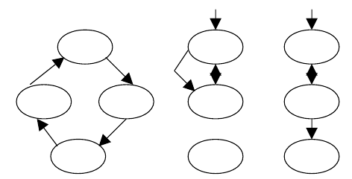

fig 5.1 Flow graph

Here each circle represents one or more non branching procedural language or source code statements in Flow Graph. While performing Condition Testing Domain Testing methodology was selected. While performing Loop Testing simple loops, concatenated loops, nested and unstructured loops were tested thoroughly.

* **TEST CHARACTERS** :

1.A good test has a high probability of finding an error.

2.A good test is not redundant.

3.A good test should be “best of breed”.

4.A good test should be neither too simple nor too complex.

* **BLACK BOX TESTING**:

The method of Black Box Testing is used by the software engineer to derive the required results of the test cases:

1.Black Box Testing alludes to test that are conducted at the software interface.

2.A Black Box Test examines some fundamental aspect of a system with little regard for the internal logic structure of the software.

3.A limited number of important logical paths can be selected and exercised.

4.Important data structure can be probed for validity.

Black box testing was performed to find errors in the following categories:-

* Incorrect or missing functions
* Graphics error.
* Errors in data in binary format.
* Error in data in integer format.
* File error.
* Pointer error.
* Memory access error.
* Variable error .
* Performance error
* **WHITE BOX TESTING**:

White Box Testing is sometimes called Glass Box Testing. Using White Box Testing methods the software engineer can derive the following test cases:

1. Guarantee that all independent paths within a module have been exercised at least once.

2. Exercise all logical decisions on their true and false sides.

3. Execute all loops at their boundaries and within their operational bounds.

4. Exercise internal data structures to ensure the validity.50

In White Box Testing efforts were made to handle the following:-

• Number of input parameters equal to number of arguments.

•Parameters and arguments attributes match.

• Number of arguments transmitted is called modules equal to attributes of parameters..

•Unit system of argument transmitted is called modules equal unit system of parameter.

• Number of attributes and order of arguments to build in functions correct.

•Any references to parameters not associated to build in functions correct.

•Input only arguments altered.

•Global variable definition consistent across module.

•Files attributes correct.

•Format specifications matches I/O specification.

•Files opened before use.

•File closed while working is going on.

•I/O errors handled.

• Any textual errors in output information.

* **UNIT TESTING**:

The unit testing is performed to test the validity of the individual units. This is done in the coding phase with the interactive testing. Thus it itself constitutes a majority of functionality test for each logical unit.

* **INTEGRITY TESTING**:

When all the development of all the units or modules is completed and integrated the integrity test phase is started. In this phase the interface between the modules are tested. This phase basically verifies whether inter module exchange of information and events are as per required system behavior.

* **VALIDATION TESTING :**

Tests were performed to find conformity with the requirements. Plans and procedures were designed to ensure that all functional requirements are satisfied. The software was alpha-tested. There are two goals in preparing test plans. Firstly, a properly detailed test plan demonstrates that the program specifications are understood completely. Secondly, the test plan is used during program testing to prove the correctness of the program.

**TEST CASES**

**Login:**

|  |  |  |  |  |
| --- | --- | --- | --- | --- |
| **Sl No** | **Input Values** | **Test case** | **Conditional being checked** | **Result** |
| 1 | Email | Empty | Please Enter valid Username | Successful |
| 3 | Email | Already Exists or not | Login ID should be unique | Successful |
| 4 | Password | Empty | Please Enter valid Password | Successful |
| 5 | Password | If wrong Password | Enter Password | Successful |
| 6 | Password | Length | Length should be less than or equal to 10 character | Successful |

Table 1 login table

**Registration:**

|  |  |  |  |  |
| --- | --- | --- | --- | --- |
| **Sl No** | **Input Values** | **Test case** | **Conditional being checked** | **Result** |
| 1. | First Name | Empty | It must not be empty | Successful |
| 2 | **Country** | Select | Choose Country | Successful |
| 3 | **Email** | Empty | Enter valid Email ID. | Successful |
| 4 | **Password** | Empty | Enter valid Password. | Successful |
| 5 | **Password** | Length | Minimum 8 characters required | Successful |
| 6 | **Confirm Password** | Empty | Password and confirmation password must be same | Successful |
| 7 | **City** | Select | Choose city | Successful |
| 8 | **State** | Select | Choose State | Successful |
| 9 | **Date Of Birth** | Select | Enter valid Username and Password. | Successful |
| 10 | **Security Question** | Select | Choose security question | Successful |
| 11 | **Security Answer** | Empty | Enter Security Answer | Successful |
| 12 | **Gender** | Select | Must not be Empty | Successful |

Table 2 Registration table

**Edit Profile:**

|  |  |  |  |  |
| --- | --- | --- | --- | --- |
| **Sl No** | **Input Values** | **Test case** | **Conditional being checked** | **Result** |
| 1. | Status | Null | Status must not be empty | Successful |
| 2 | Last Name | Empty | Last Name must not be empty | Successful |
| 3 | City | Empty | City must not be empty | Successful |
| 4 | State | Empty | state must not be empty | Successful |
| 5 | Pin code | Empty | PIN code must not be empty | Successful |
| 6 | Country | SELECT | Please select country | Successful |
| 7 | High School | Empty | High School must not be empty | Successful |
| 8 | College | SELECT | Please select college | Successful |
| 9 | Course | Empty | Course must not be empty | Successful |

Table 3 Profile table

**Photos:**

|  |  |  |  |  |
| --- | --- | --- | --- | --- |
| **Sl No** | **Input Values** | **Test case** | **Conditional being checked** | **Result** |
| 1. | Image Title | Null | Image title must not be empty | Successful |
| 2 | Add Image | BROWSE | Please browse image | Successful |
| 3 | Delete Image | Select | Please select image to delete | Successful |
| 4 | Description | Null | Enter Something about image or Keep empty | Successful |

Table 4 Photos table

**Scope of future application**

***SCOPE-:***

* This system provides users to register their various types of profile like social, personal, general, professional.
* This system provides users to send a scrap message, images, and data files to their friends. User can maintain the scrap book whatever scraps he has send to users.
* The system provides user to upload the photos so that user can maintain own album.
* This system provides user to join the communities according to their scenario.
* This system provides the user to maintain their friend list and user can update their friend list.
* This system provides user to send invitation to another friend and can add to their friend list for future.

***WORKING-:***

In “CHATTERBOX” a user can register him\her online without any difficulty. He\She has to fill a registration form to register himself\herself. All the entries is checked by the DATABASE which has already all information about the user. If all the entries are correct then a EMAIL ID and PASSWORD is given to the user, by using that ID and PASSWORD he\she can use his\her Account. If conditions are wrong then that login will be discarded. With the help of chatterbox any one can search peoples send messages, comment on post and see the posts of others.

**Conclusion**

While developing the system a conscious effort has been made to create and develop a software package, making use of available tools, techniques and resources – that would generate a proper system for ONLINE SOCIAL NETWORKING.

While making the system, an eye has been kept on making it as user-friendly. As such one may hope that the system will be acceptable to any user and will adequately meet his/her needs. As in case of any system development process where there are a number of short comings, there have been some shortcomings in the development of this system also.

There are some of the areas of improvement which couldn’t be implemented due to time constraints. One such feature was online chat where members can chat with his friends through this website. I also couldn't implement the scrap book and the selling item page for now but we still have two months of internship left in the company so defiantly we will do it in coming months.

**Bibliography**

**References : -**

[1] Prof Mishra. “*Social networking sites effect*” 14 Jan.2014 <http://articles.timesofindia.indiatimes.com/2013-06-23/india/40146190_1.html>

<http://en.wikipedia.org/wiki/SNSs_website>.

**Database System Concept**

* Abraham Silberschatz, Henry Korth, S. Sudarshan

**Internet sources**

* W3school.com
* PHPlearn.com